DBMS

ER DIAGRAM

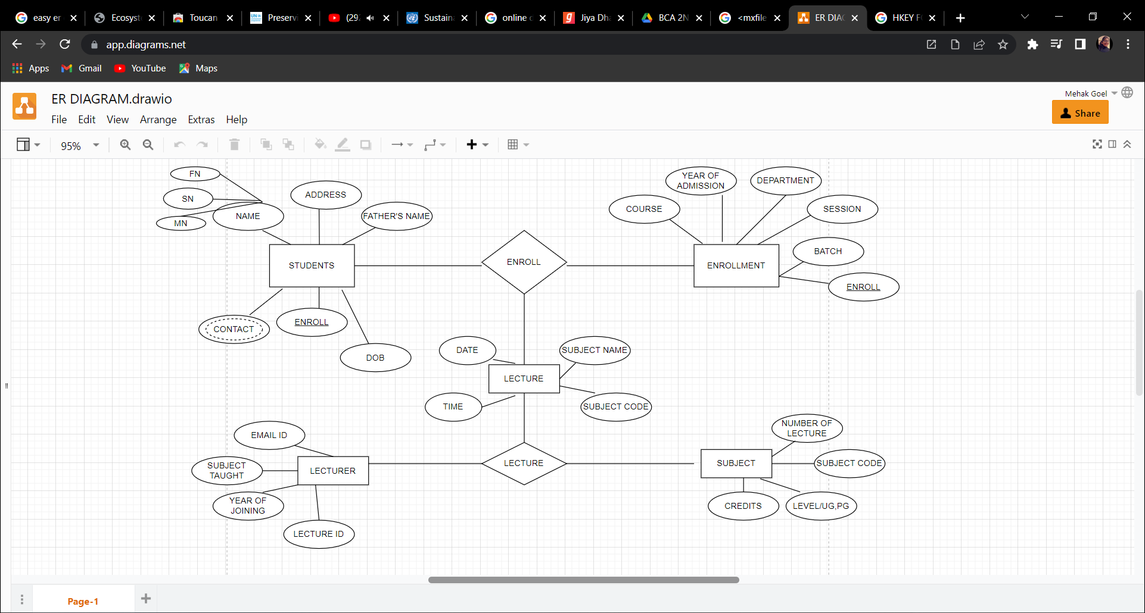

**1.Create a Database and name as College1.**

**Query:- Create database ;**

**Create database college;**

**2.Write a query to create a table named as student.**

**Create table ( type, type….)**

3.ALTER: Change the size of a particular column.

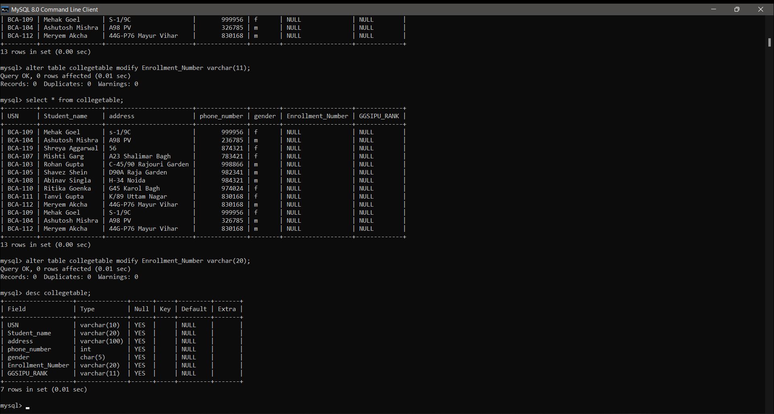

.Write a query to add a new column in a existing table. Alter table add( );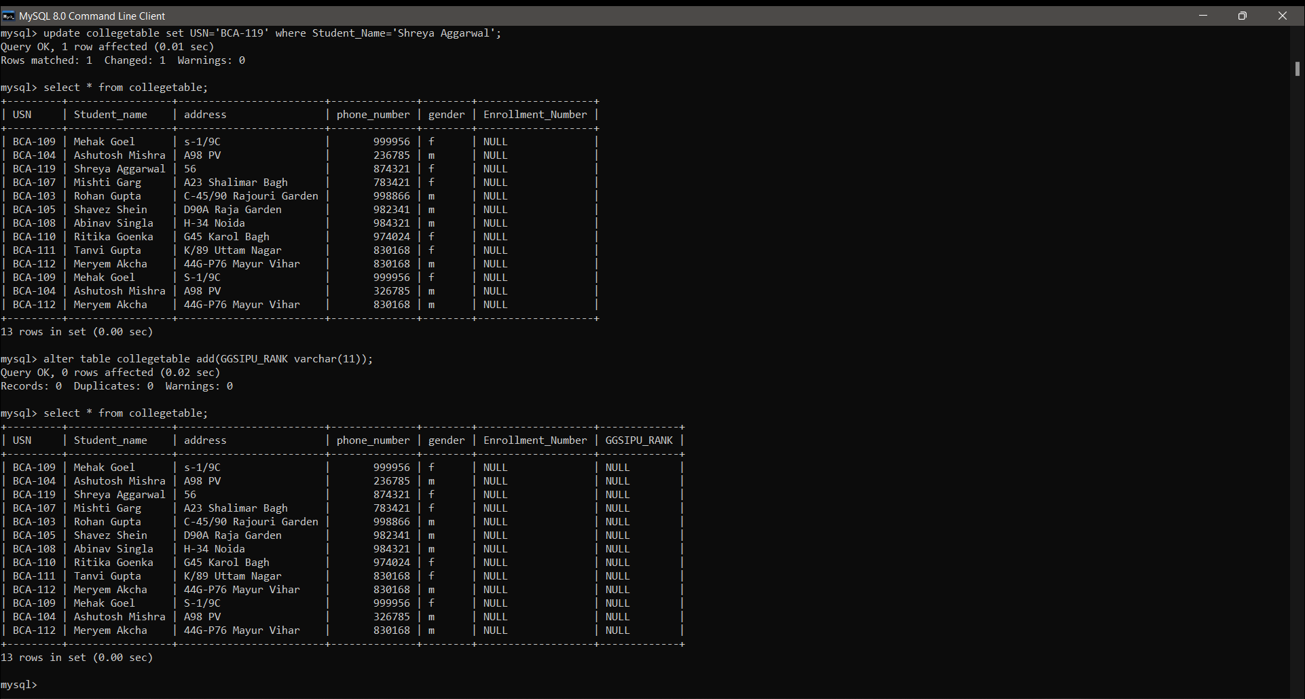

ALTER: Remove a column from the table.

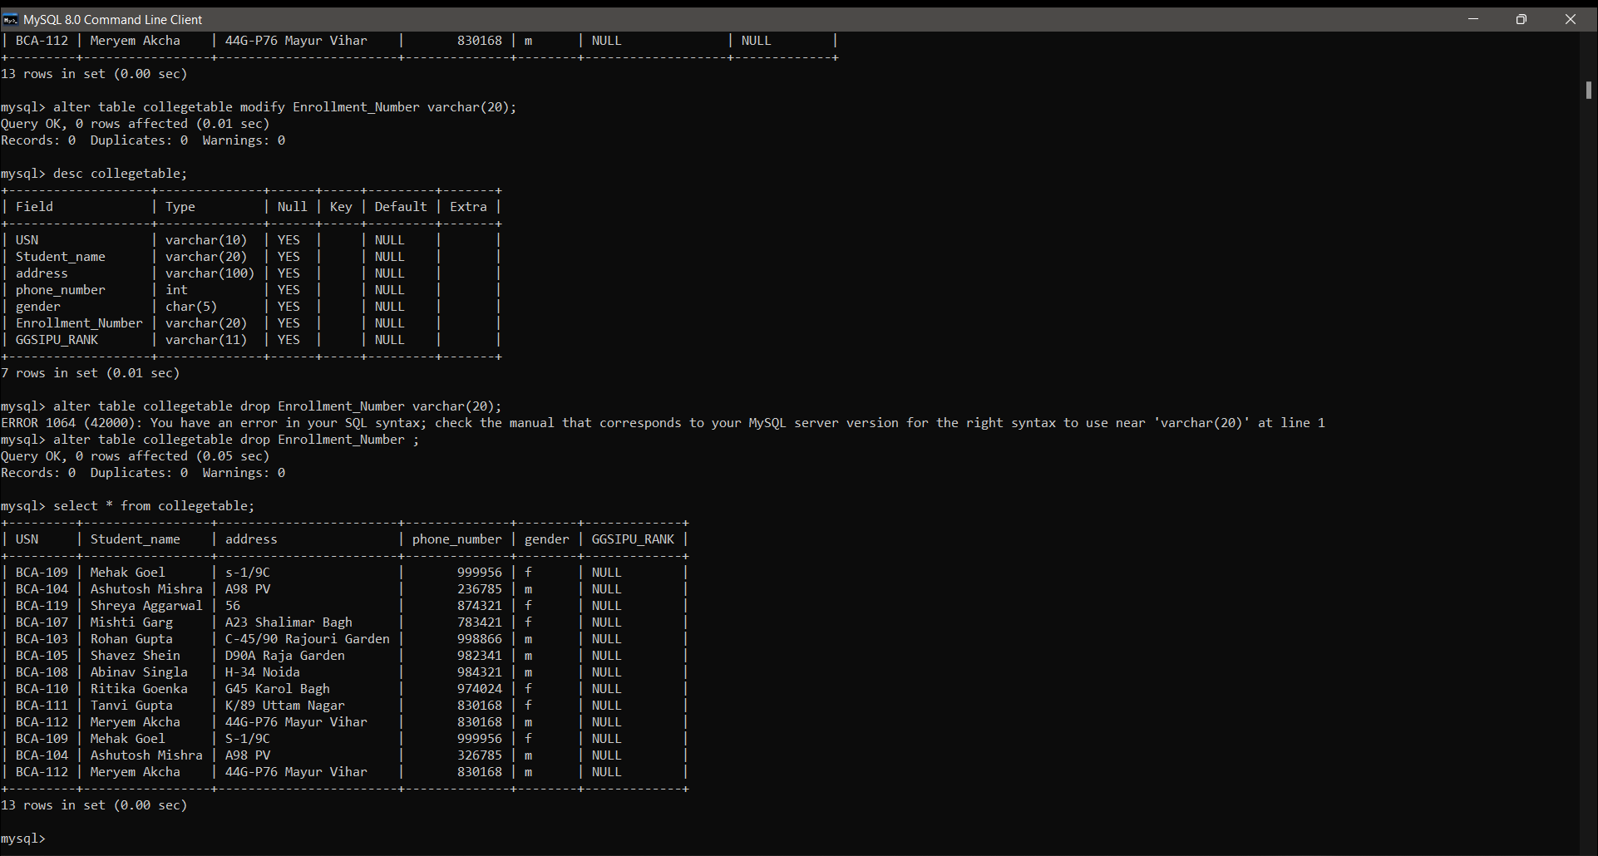

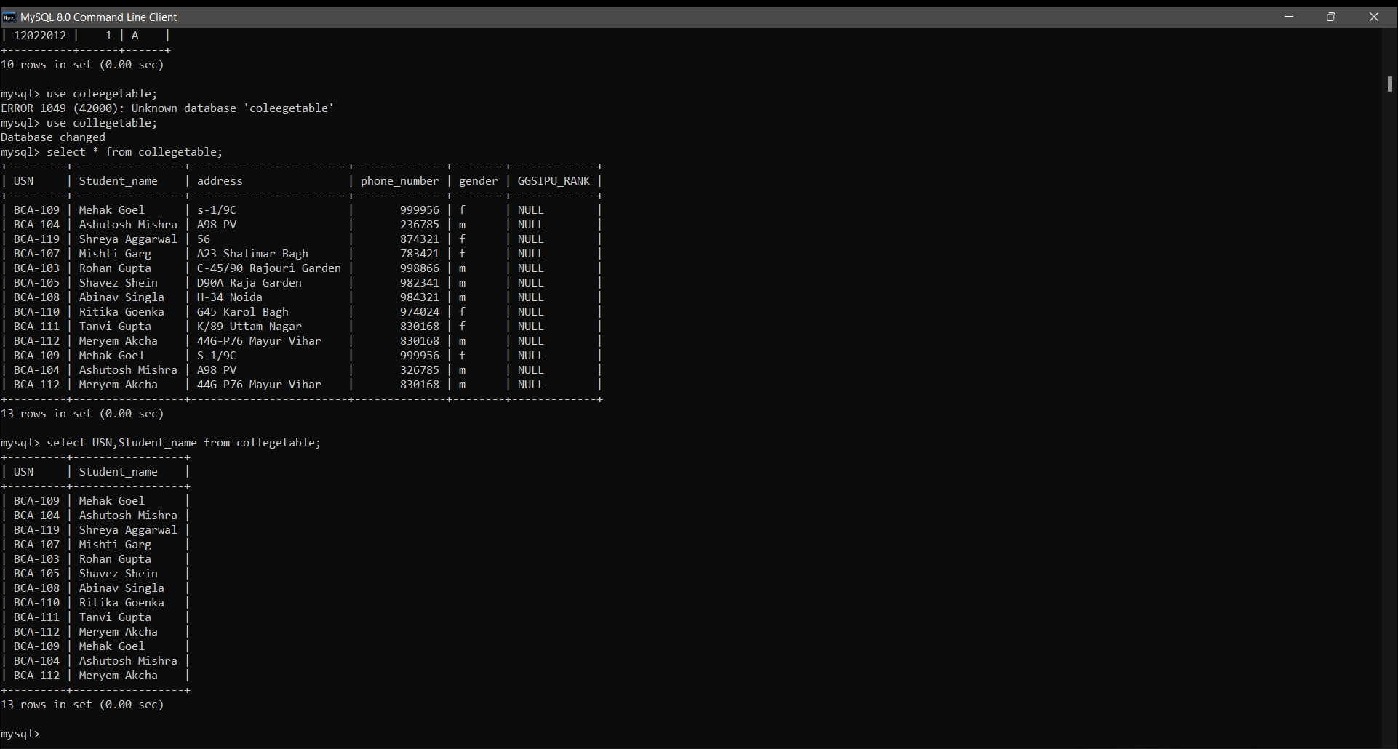

4.Distinct Column

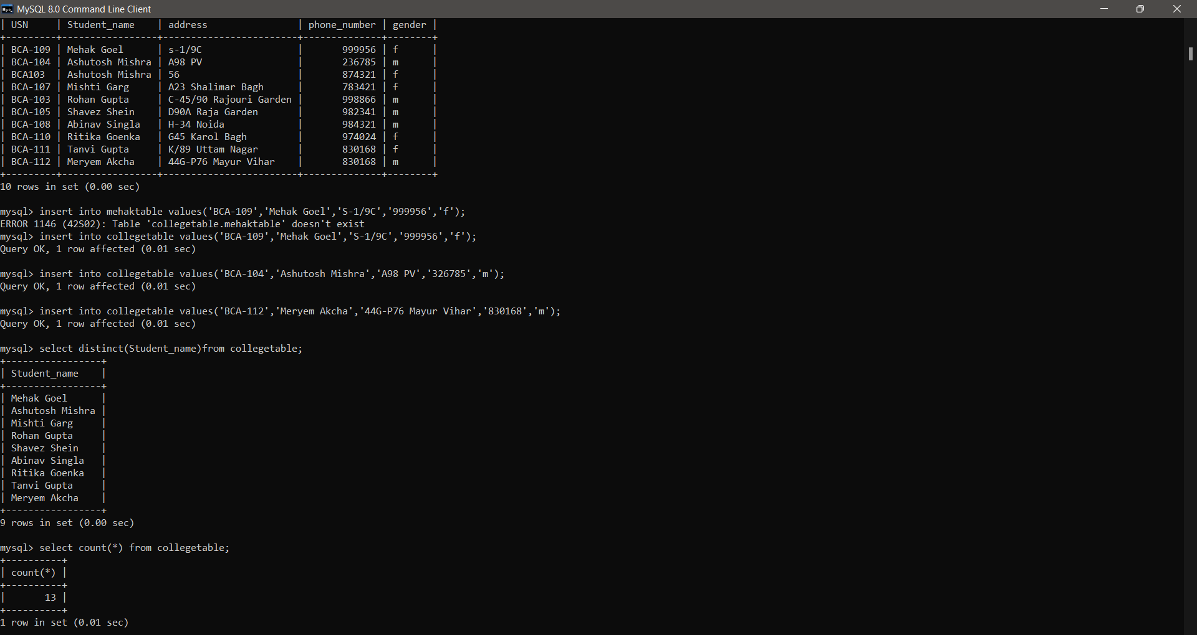

* Count*

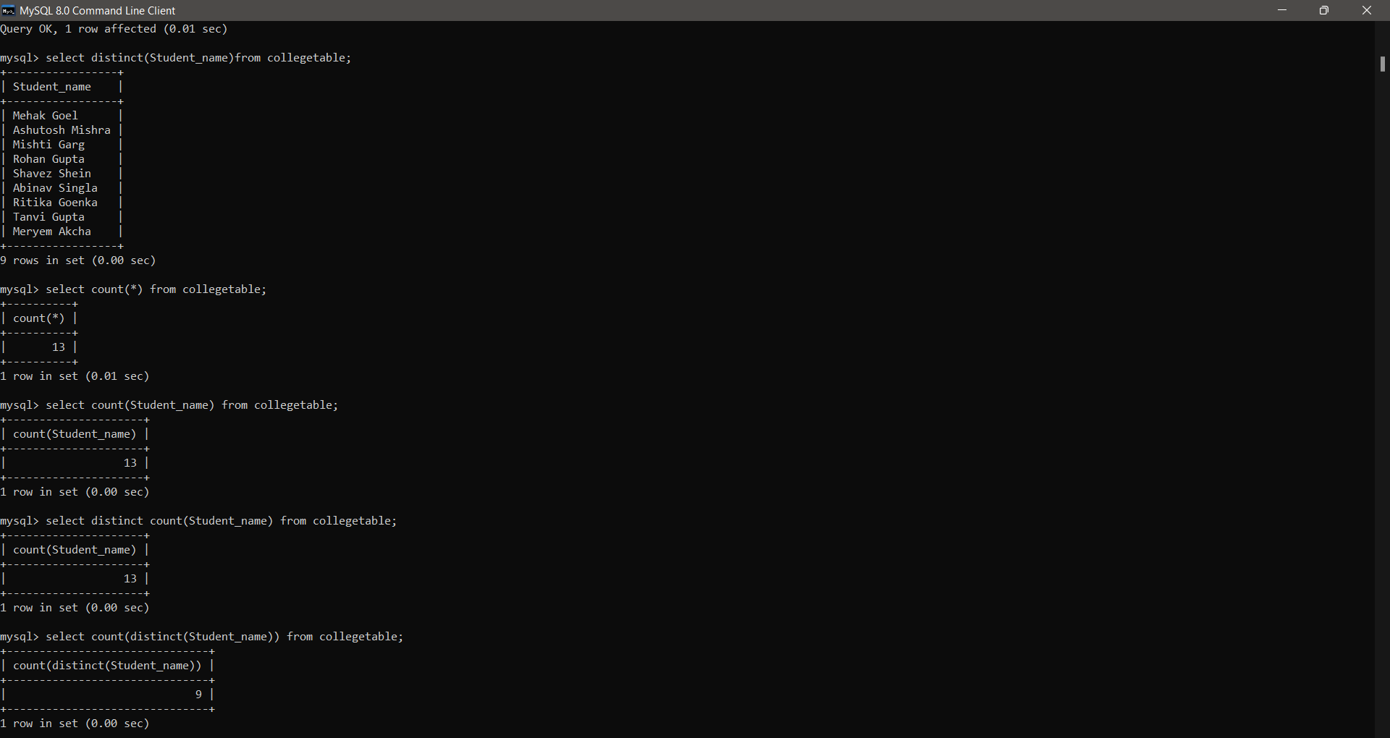

* Count column



* Distinct count



5.Assignment Operator

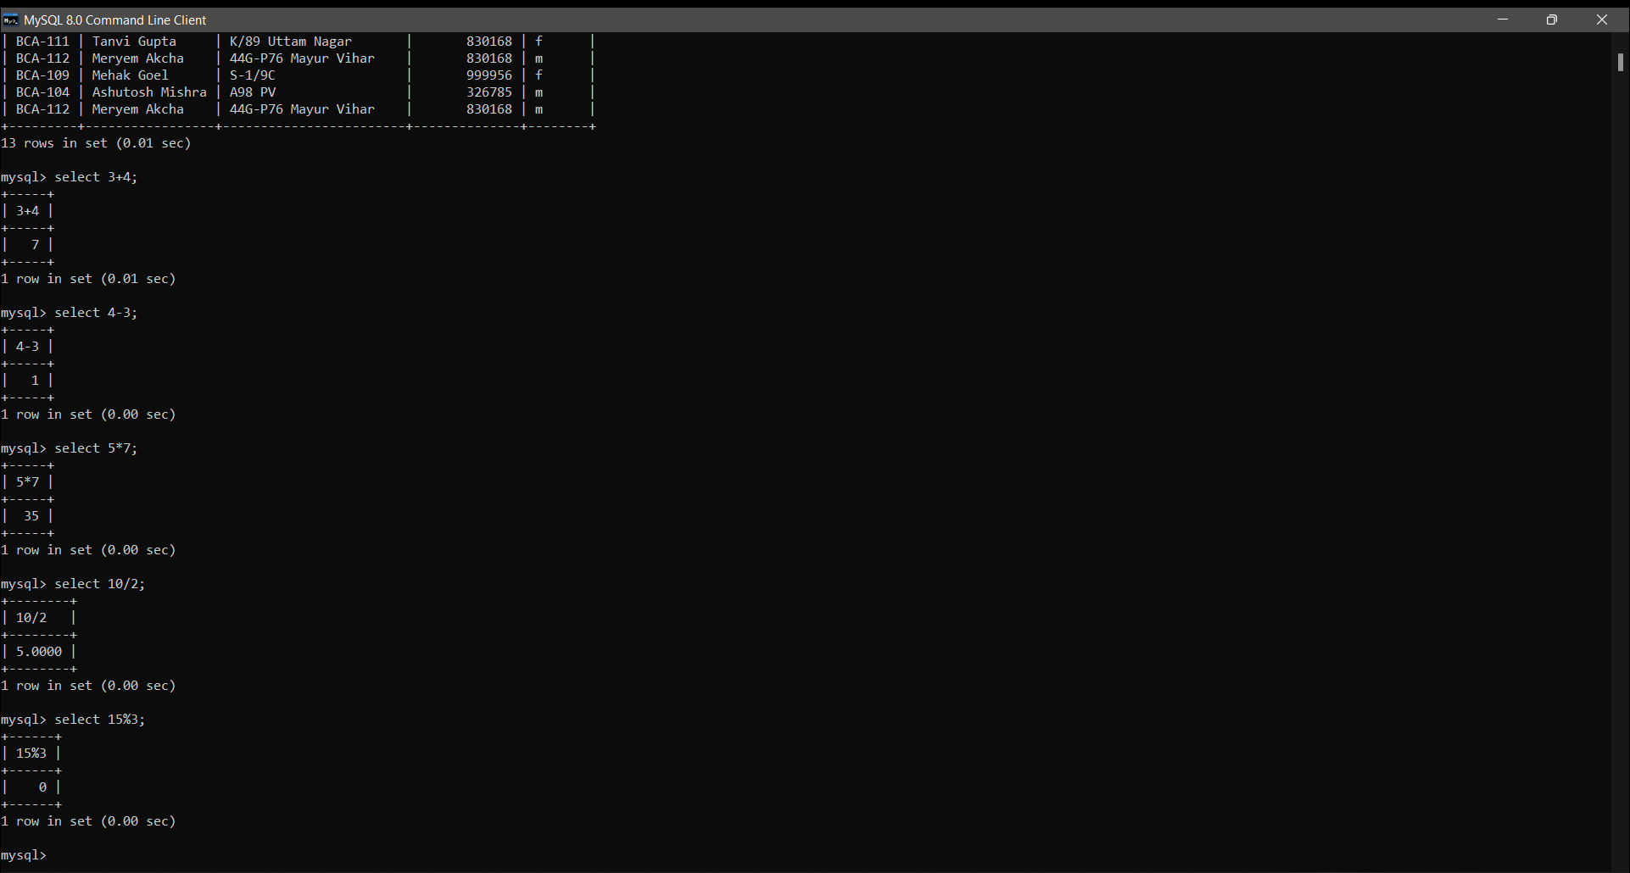

* Use Of Where Clause

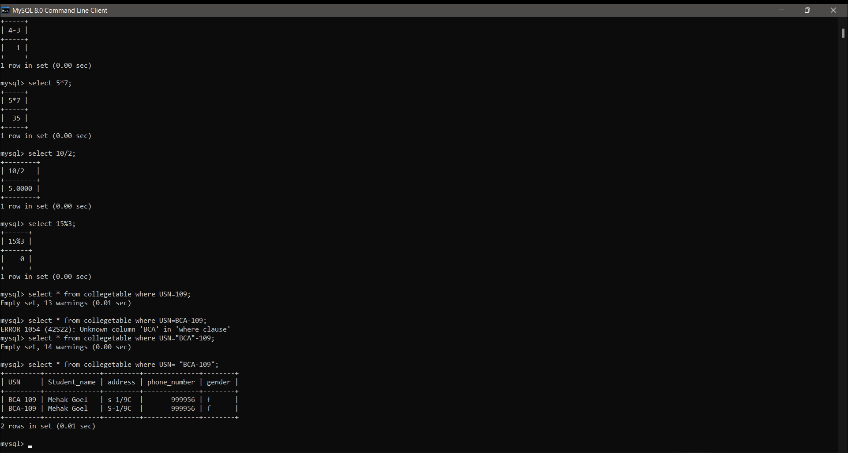

6.LOGICAL OPERATOR

* And Operator

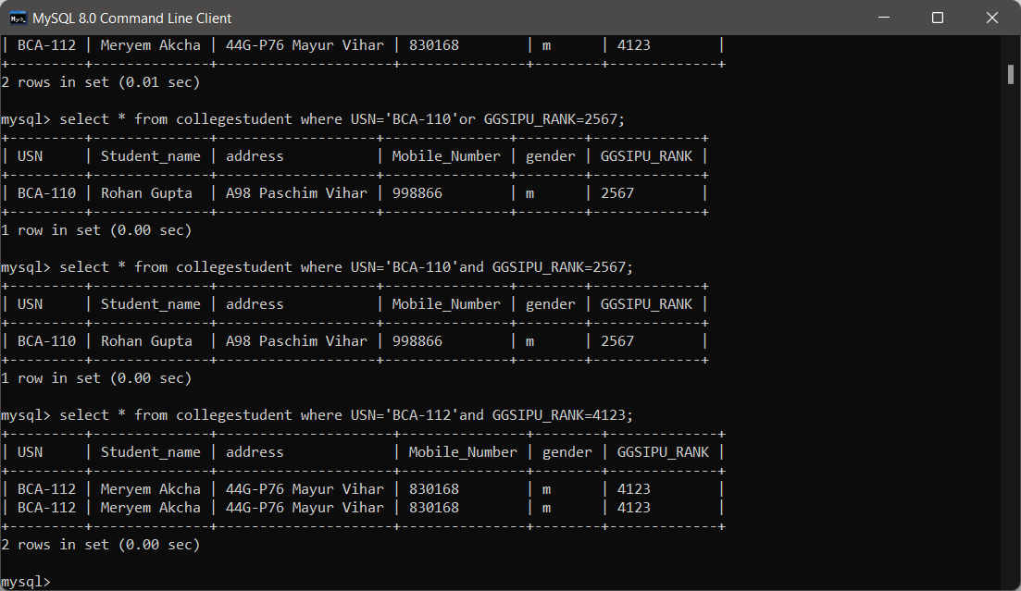

* Or Operator

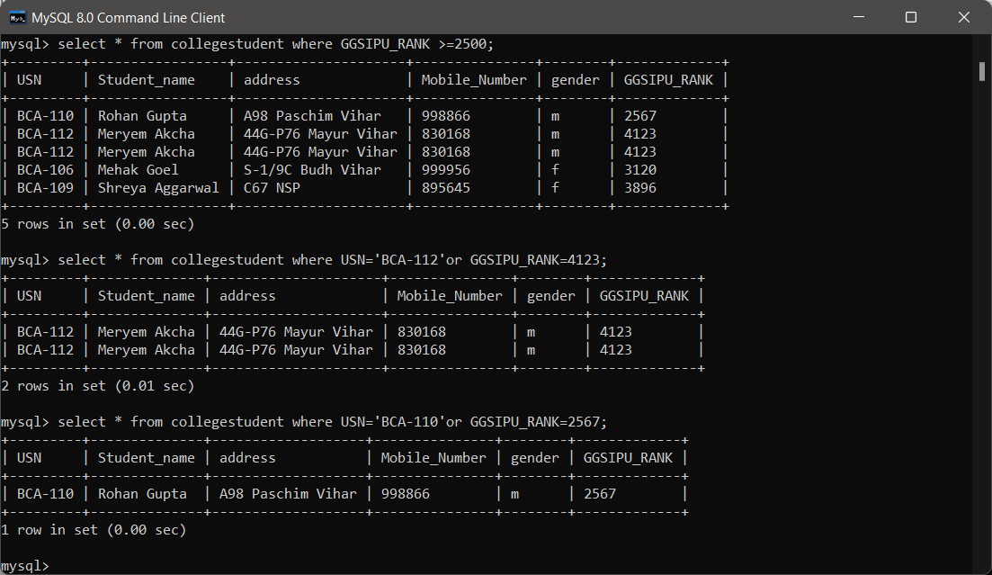

* Relational Operator

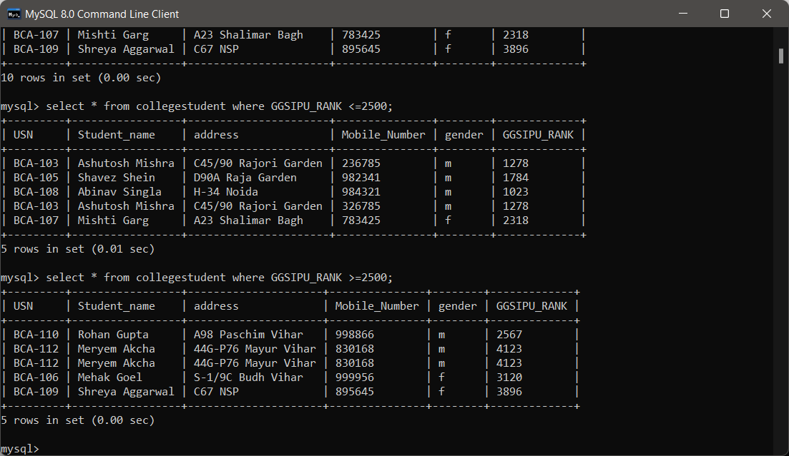

7.Deleting a Row From Table

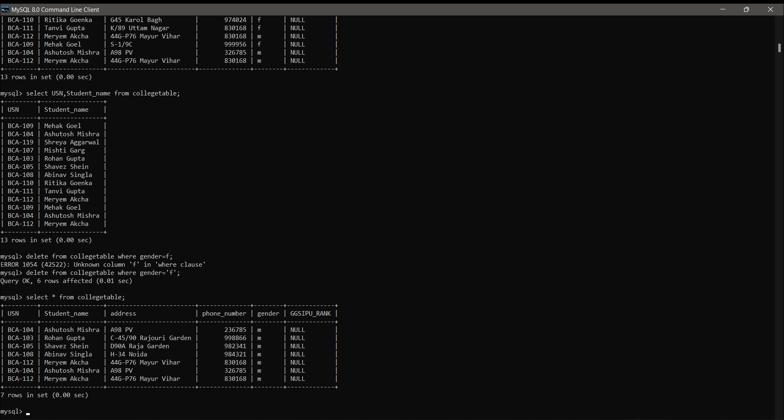

* Rename a table

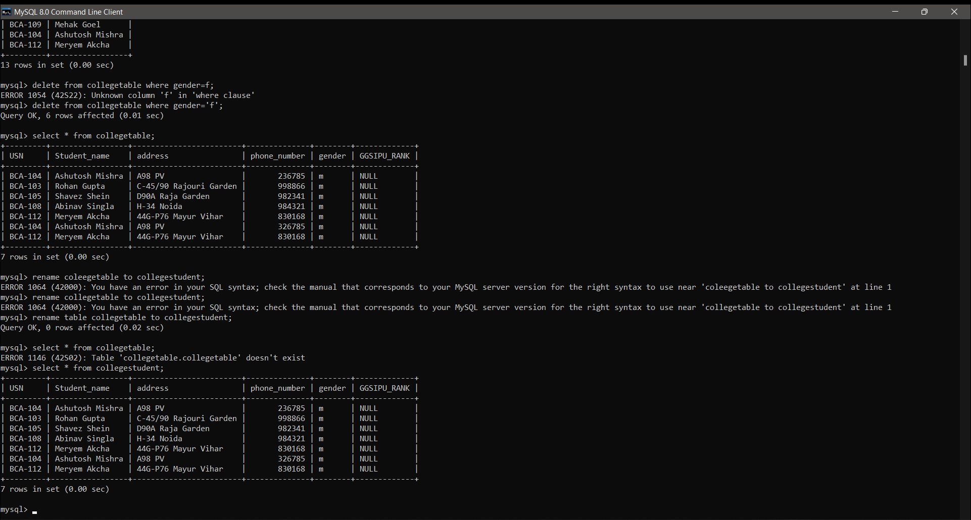

* RENAMING A TABLE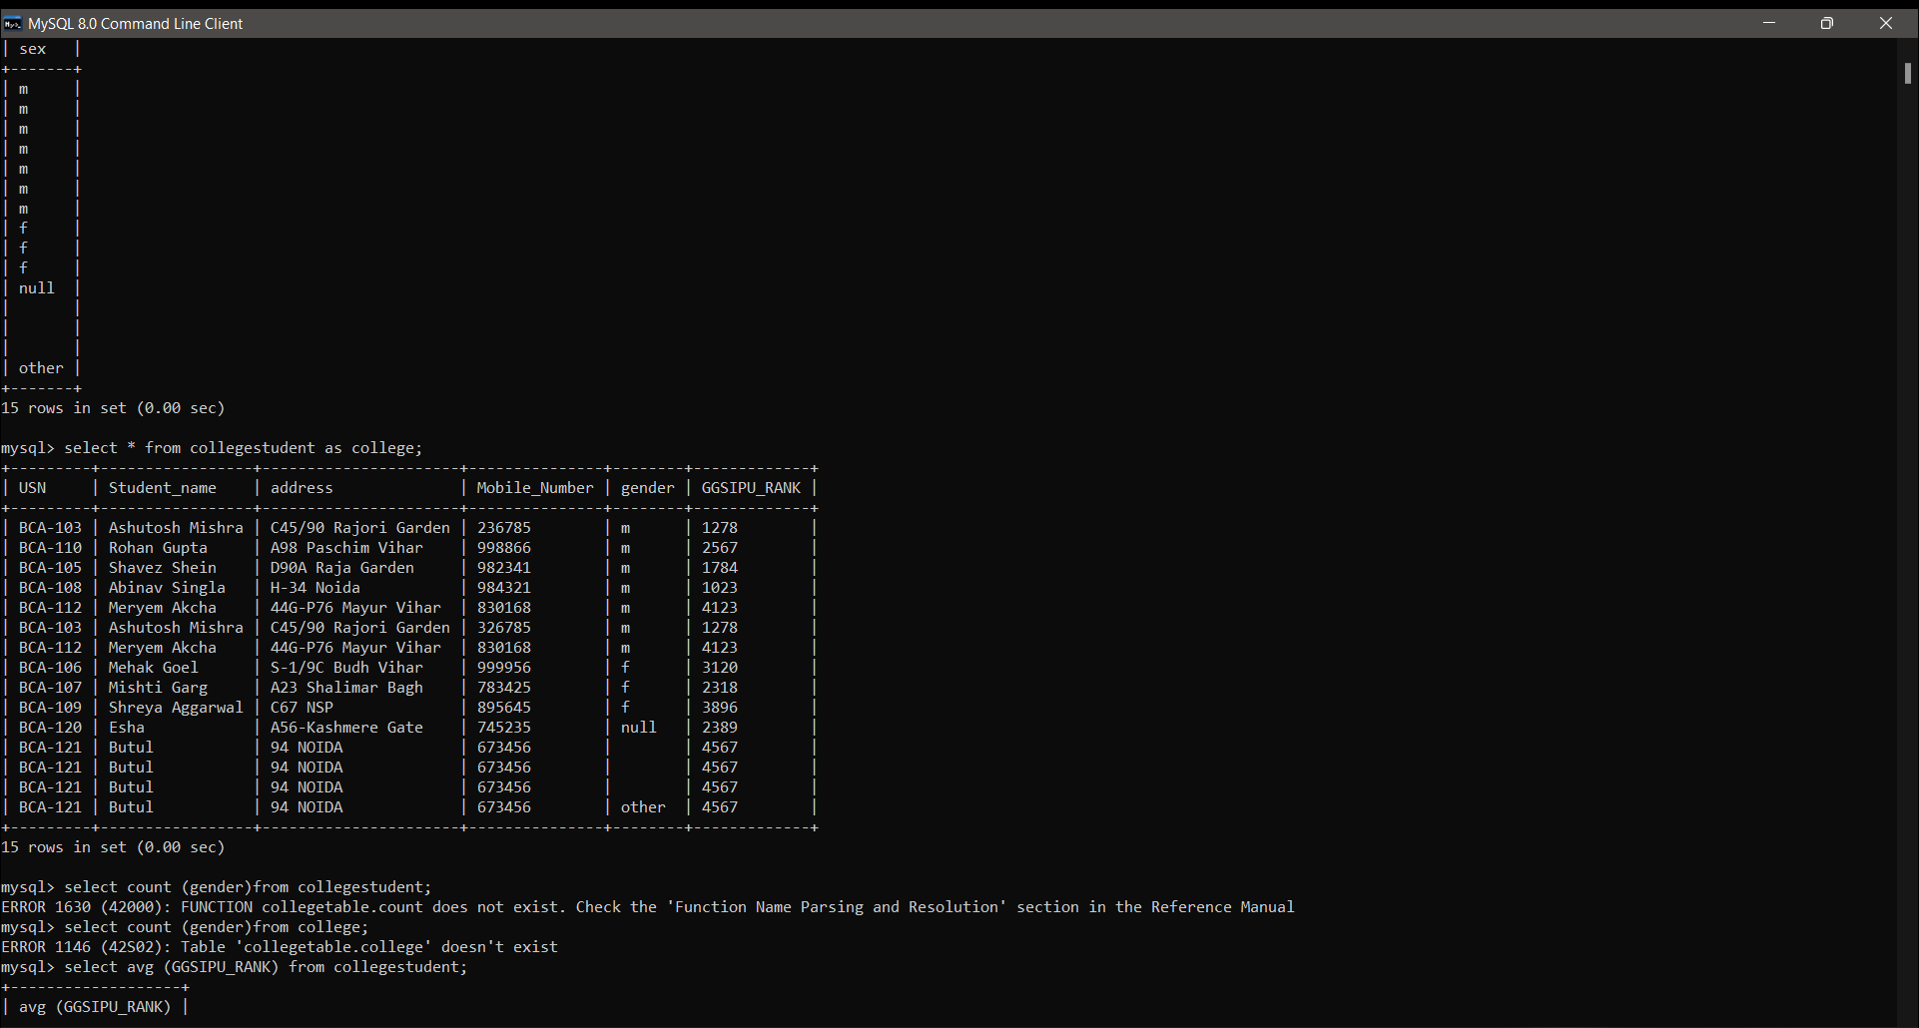

8.UPDATE: Modify data in single and multiple columns in a table

* UPDATE 1 column

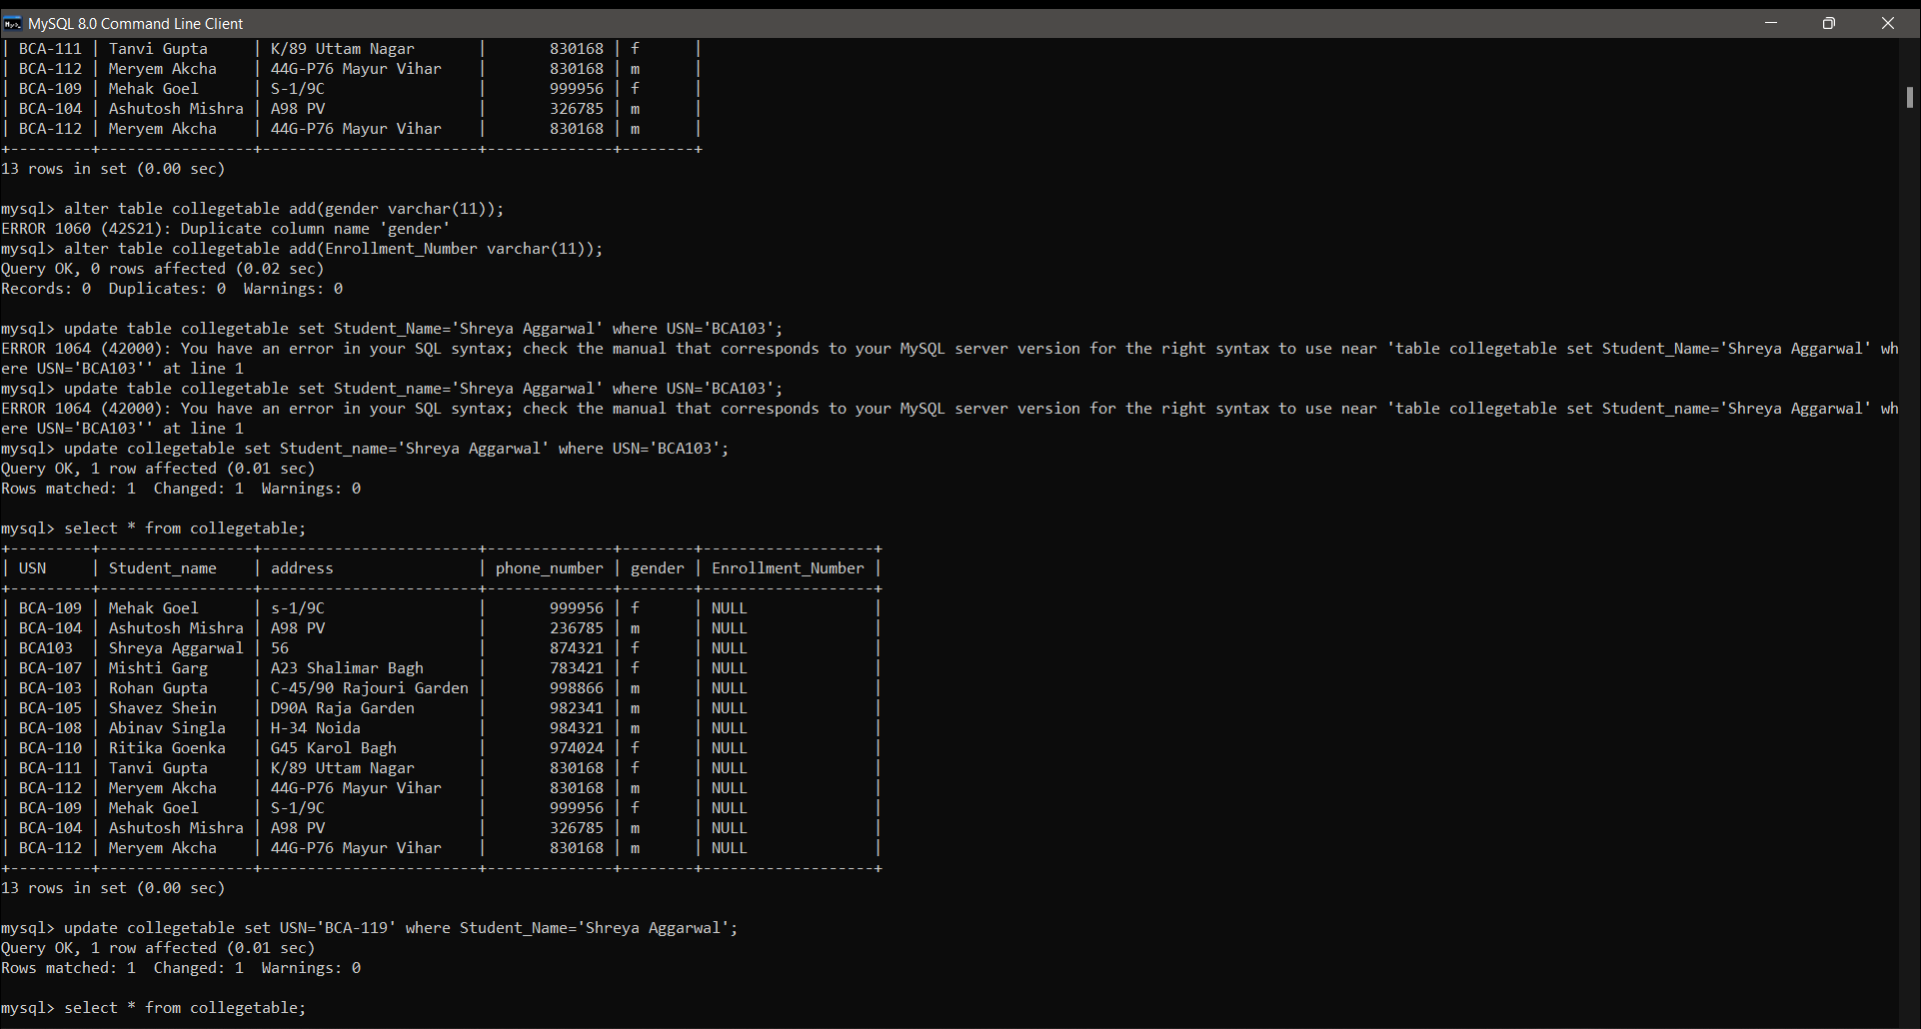

* Update 2 columns

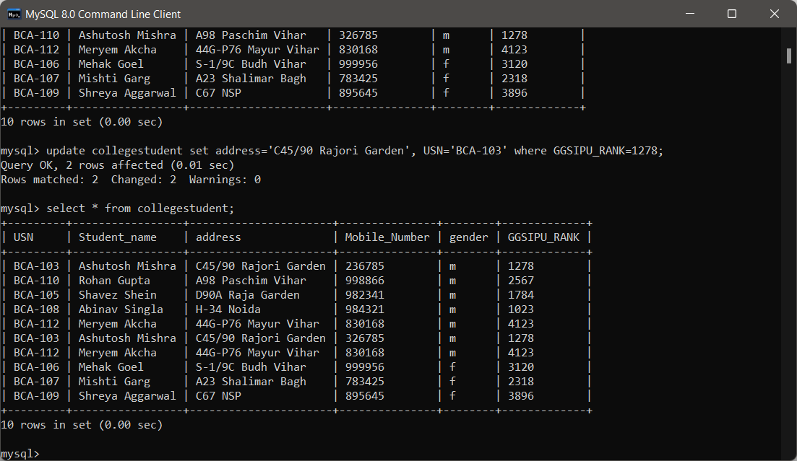

* Change column name

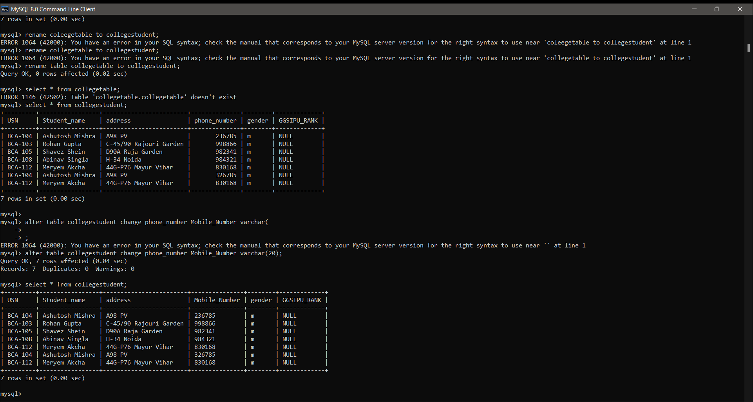

* Changing column name

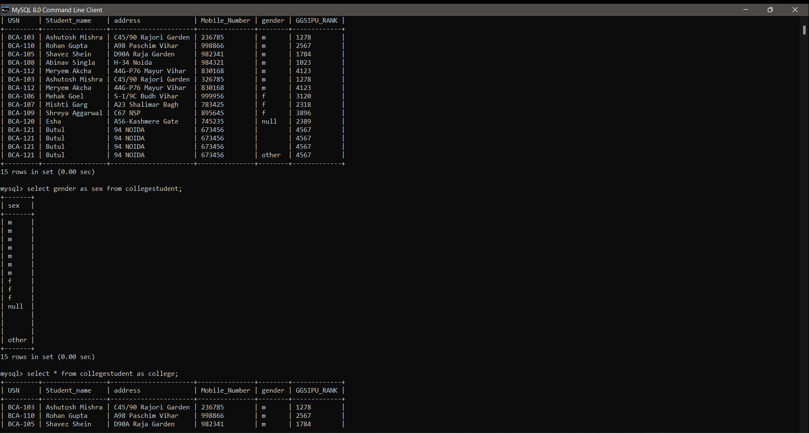

* BETWEEN

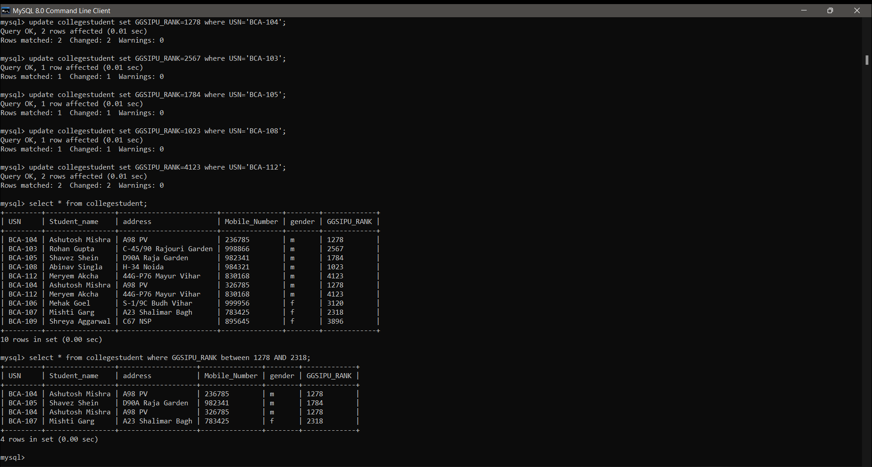

* NOT BETWEEN

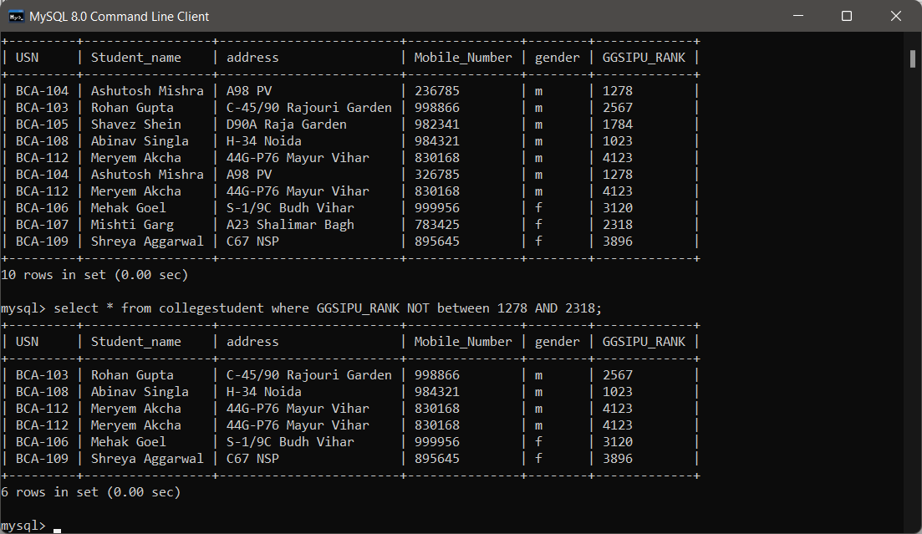

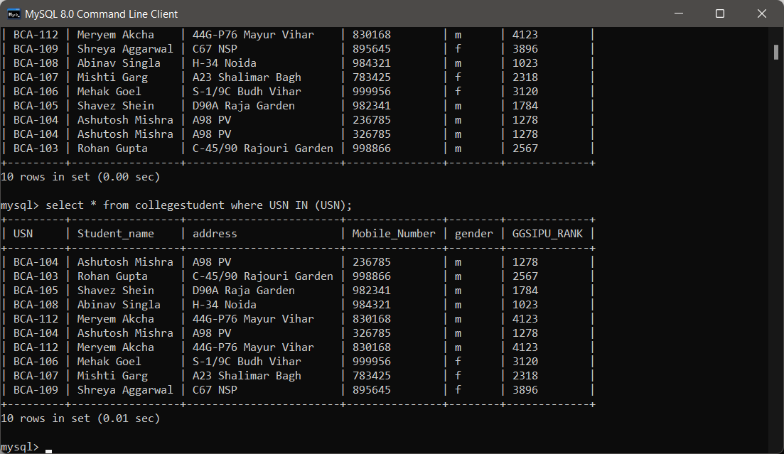

9.Sort the data in ascending and descending order in a table on the basis of one column or more than one column.

* Ascending order

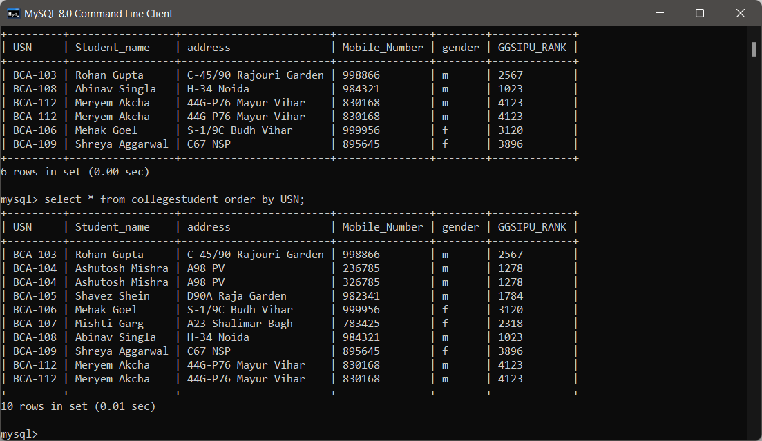

* Descending order

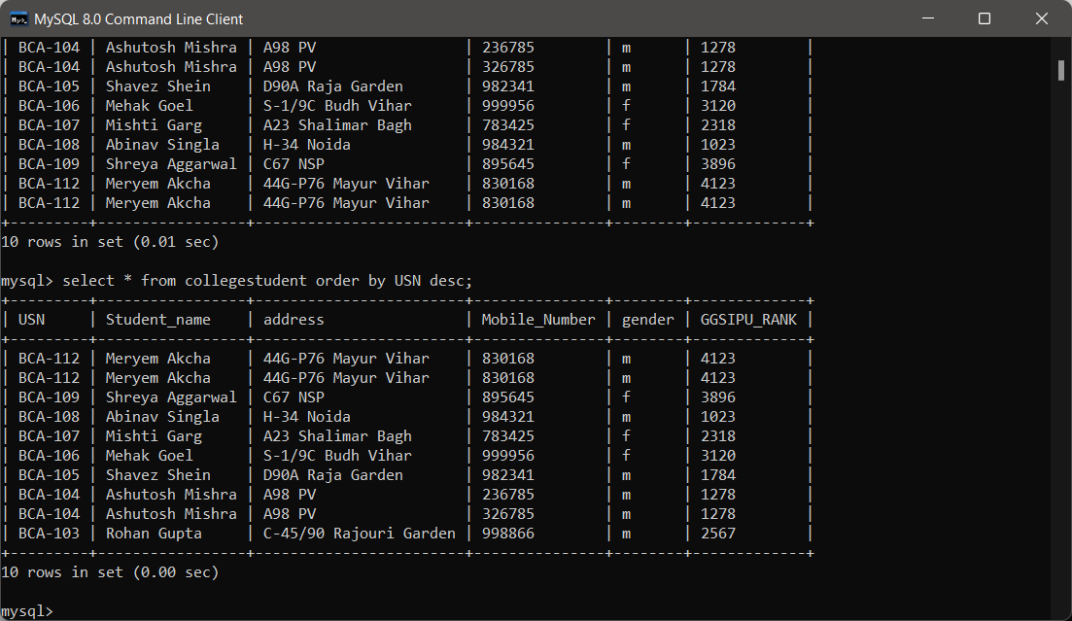

* ADDING UNIQUE KEY

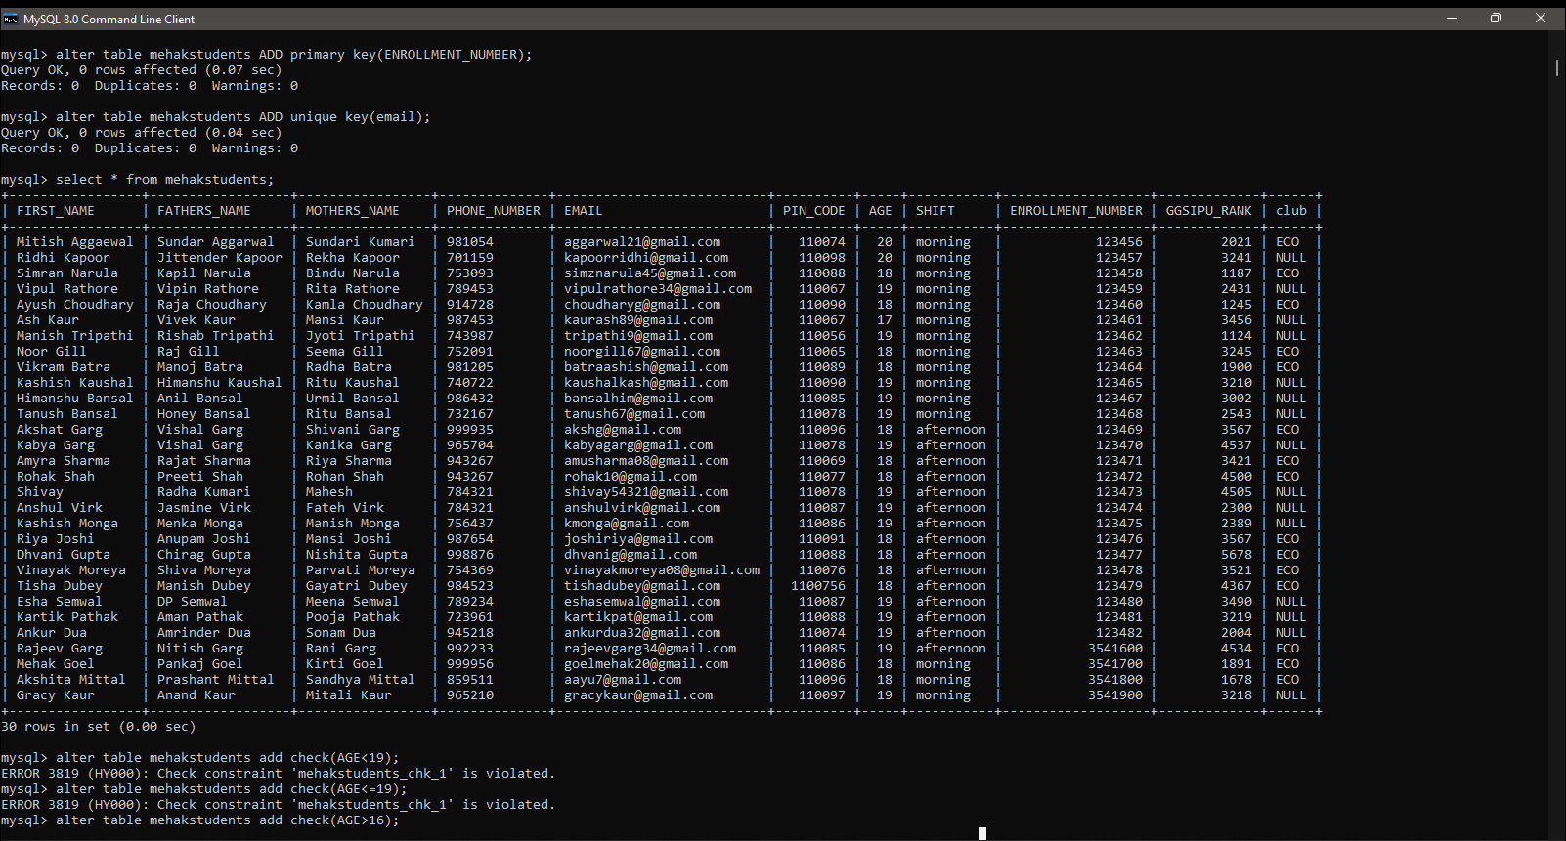

* ADD CONSTRAINT

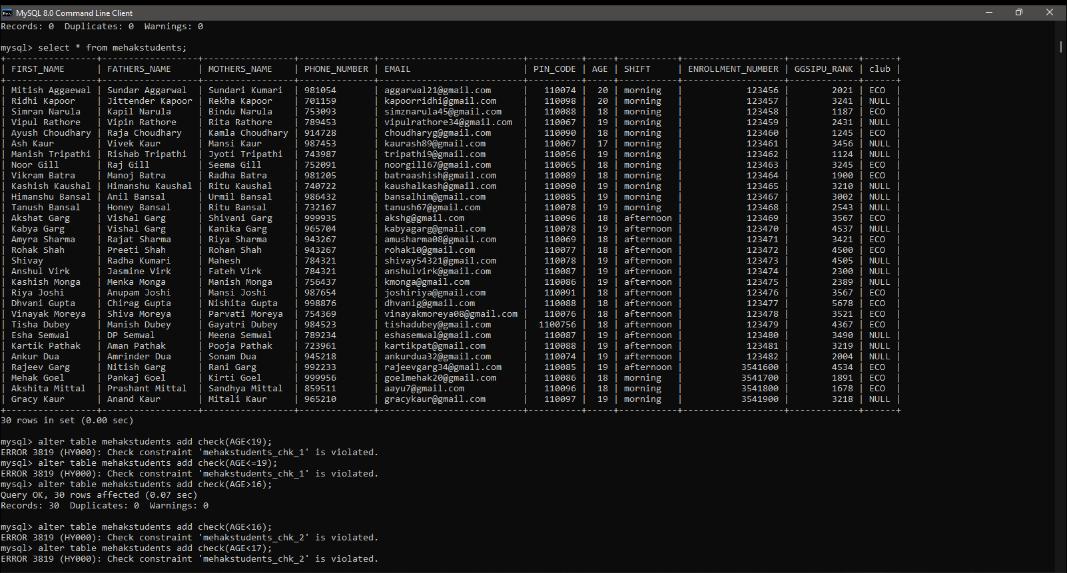

* FINDING AVERAGE

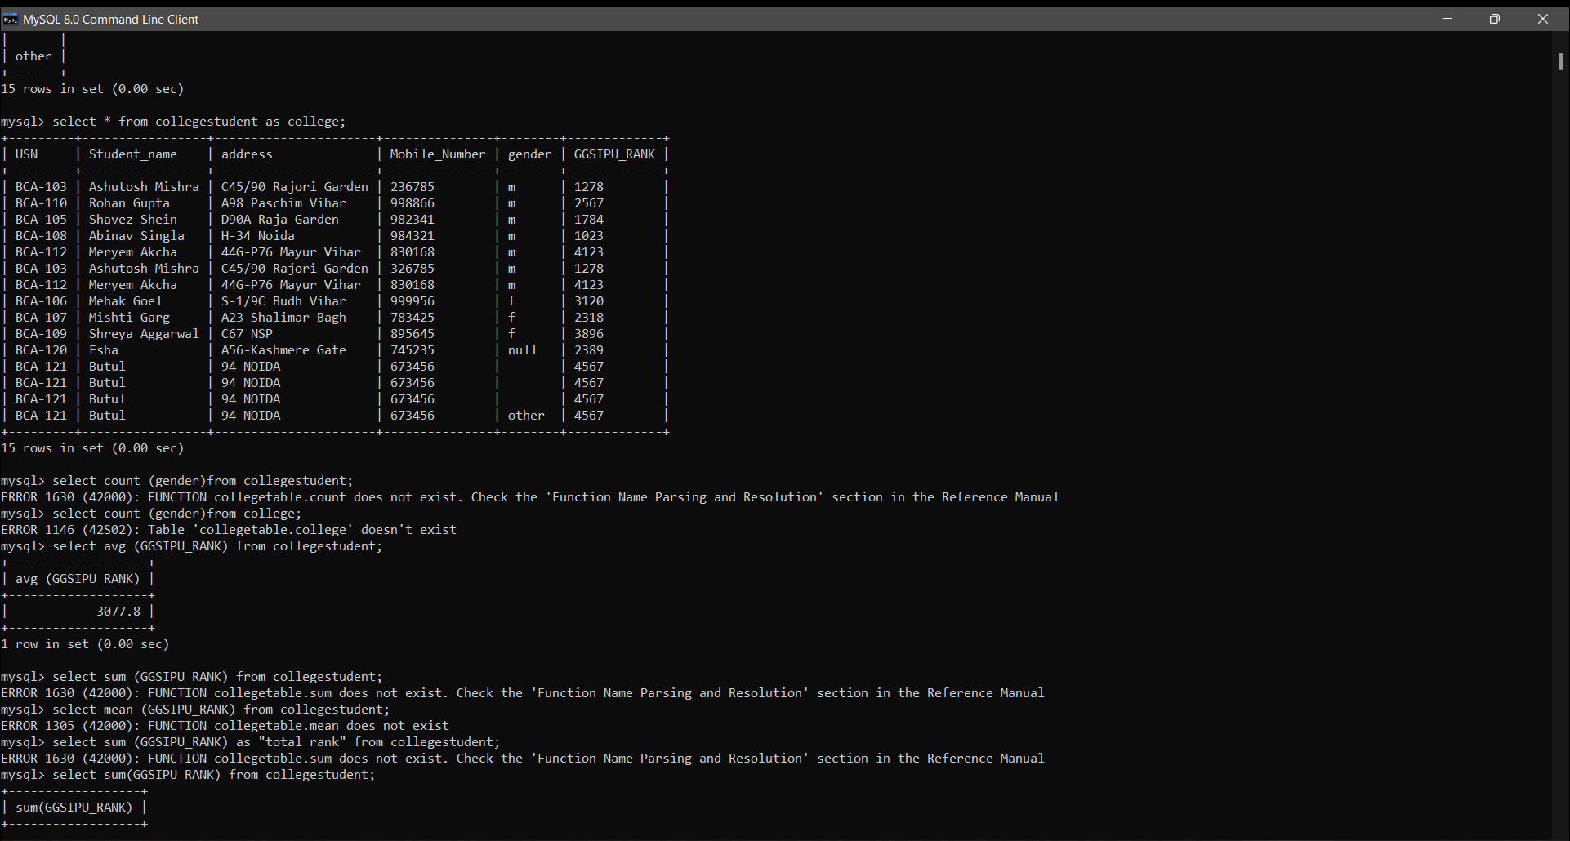

* FINDING SUM & MAX

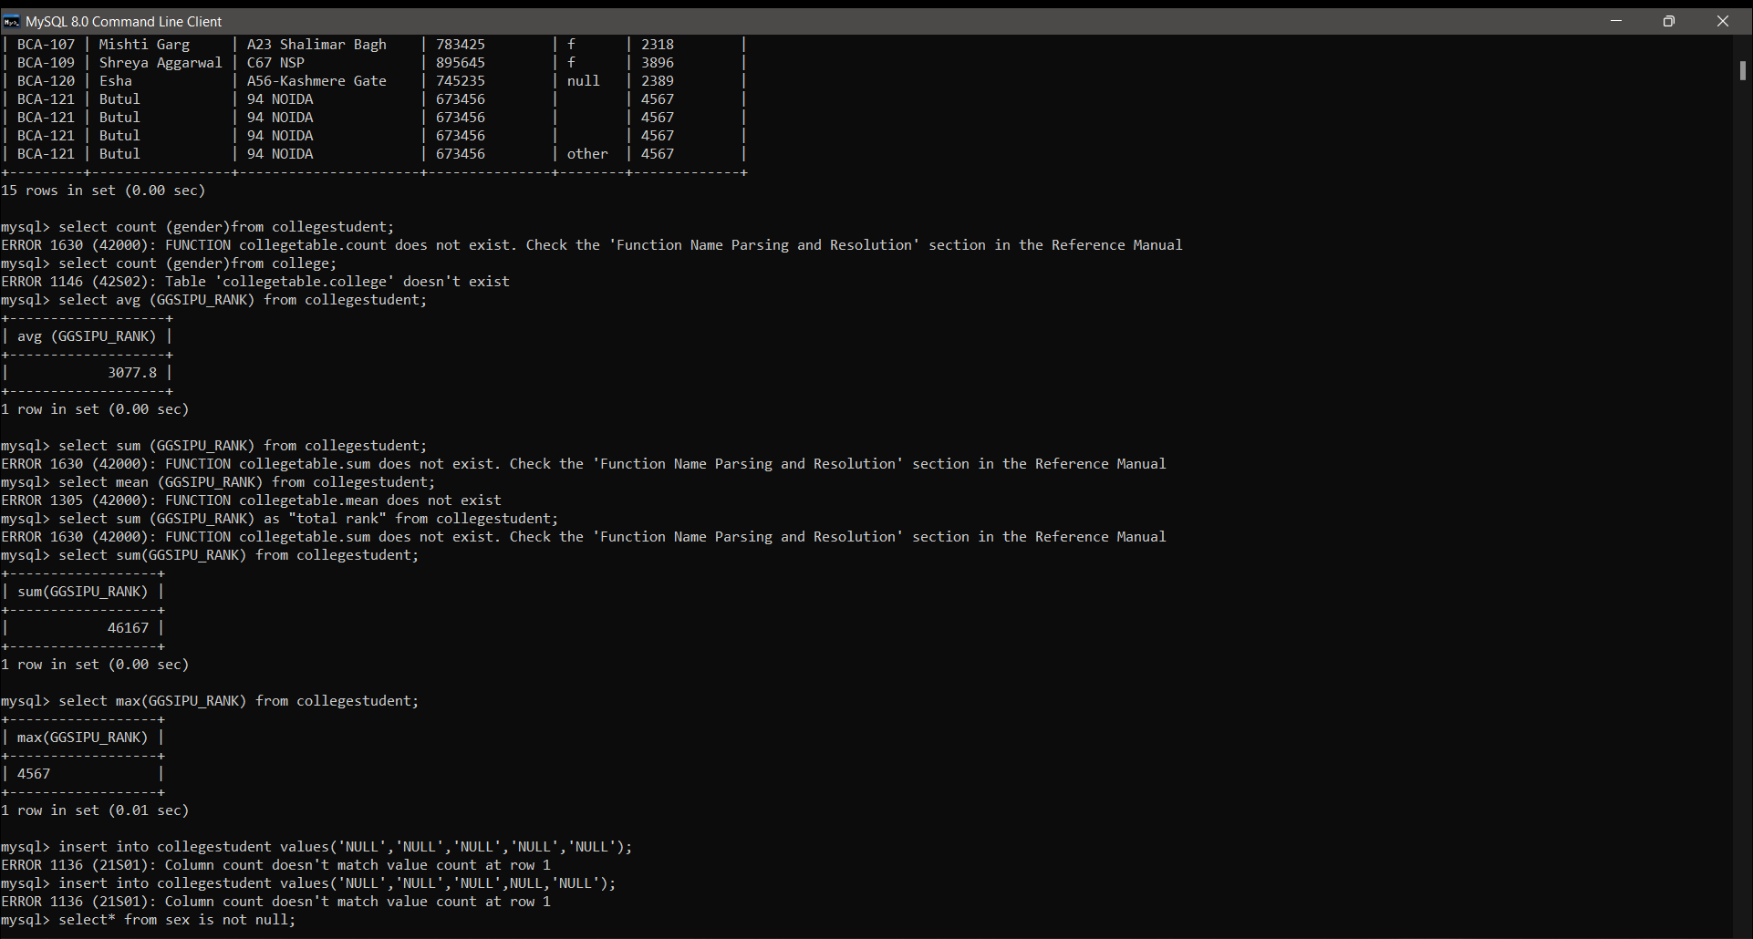

10.ADDING NULL VALUE INTO ROW OF TABLE

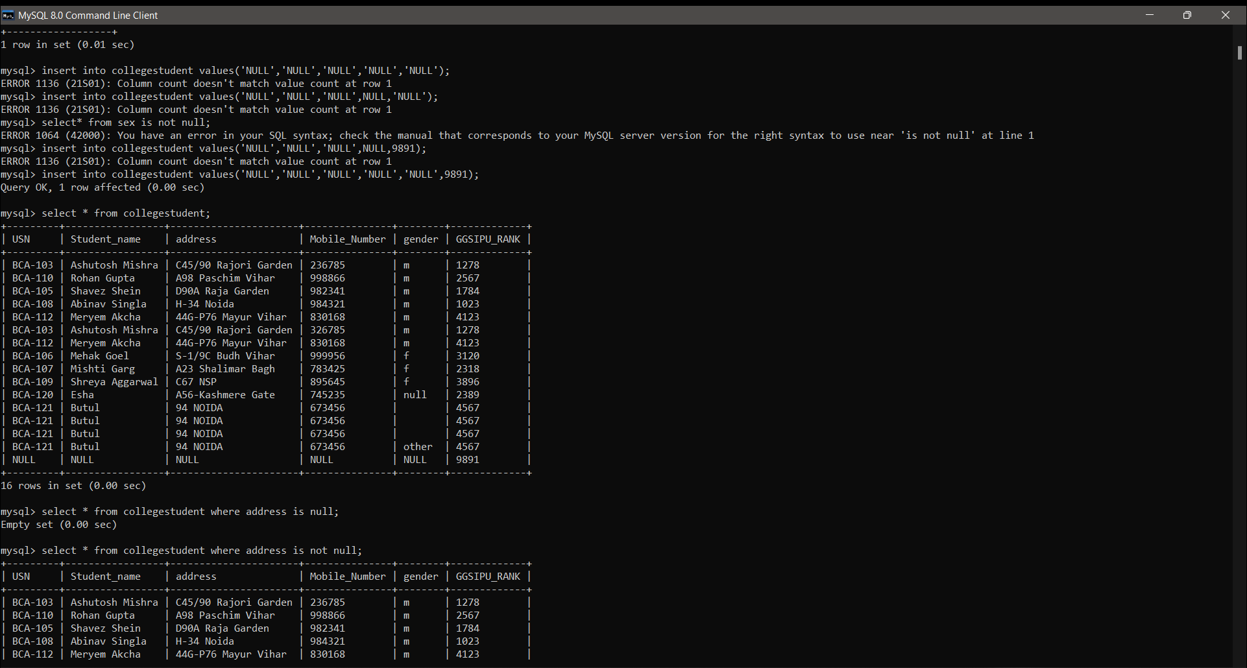

* NULL AND NOT NULL

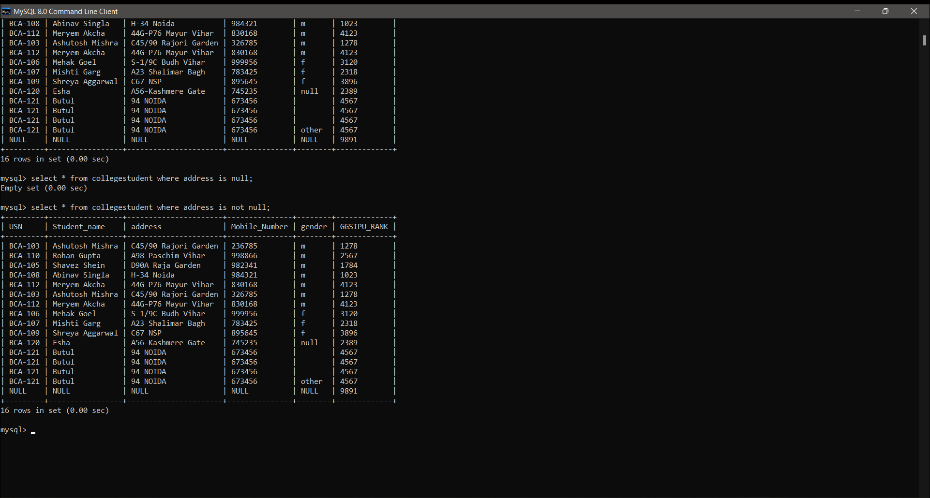

* USE OF AUTO INCREMENT

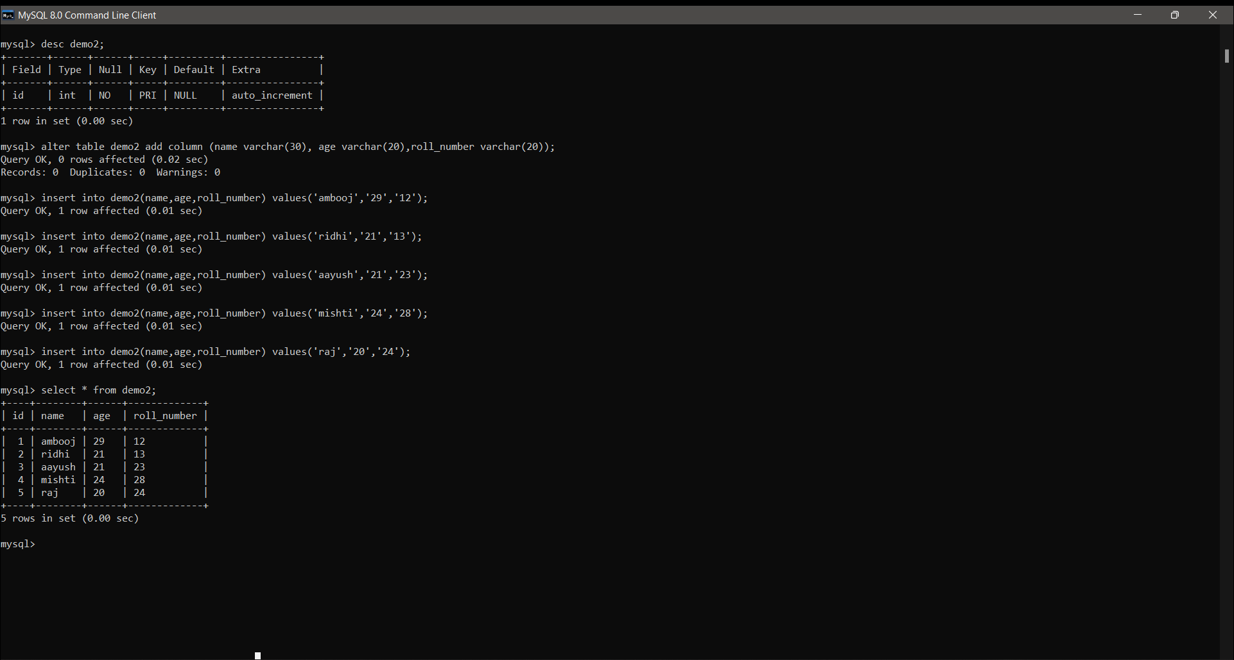

11.GROUP BY QUERY

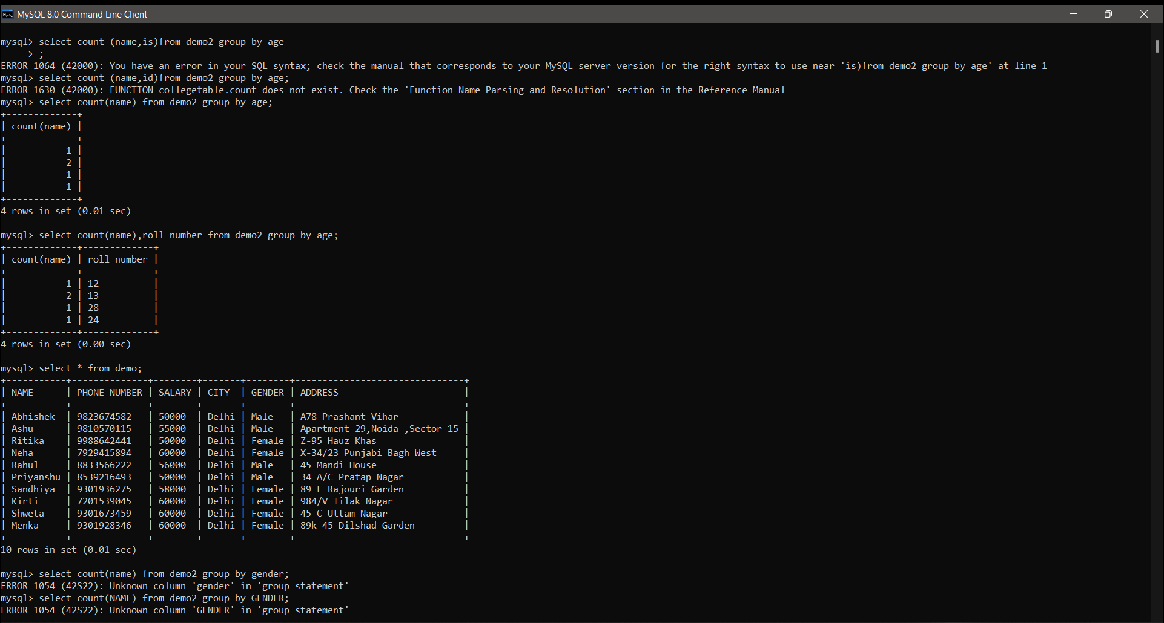

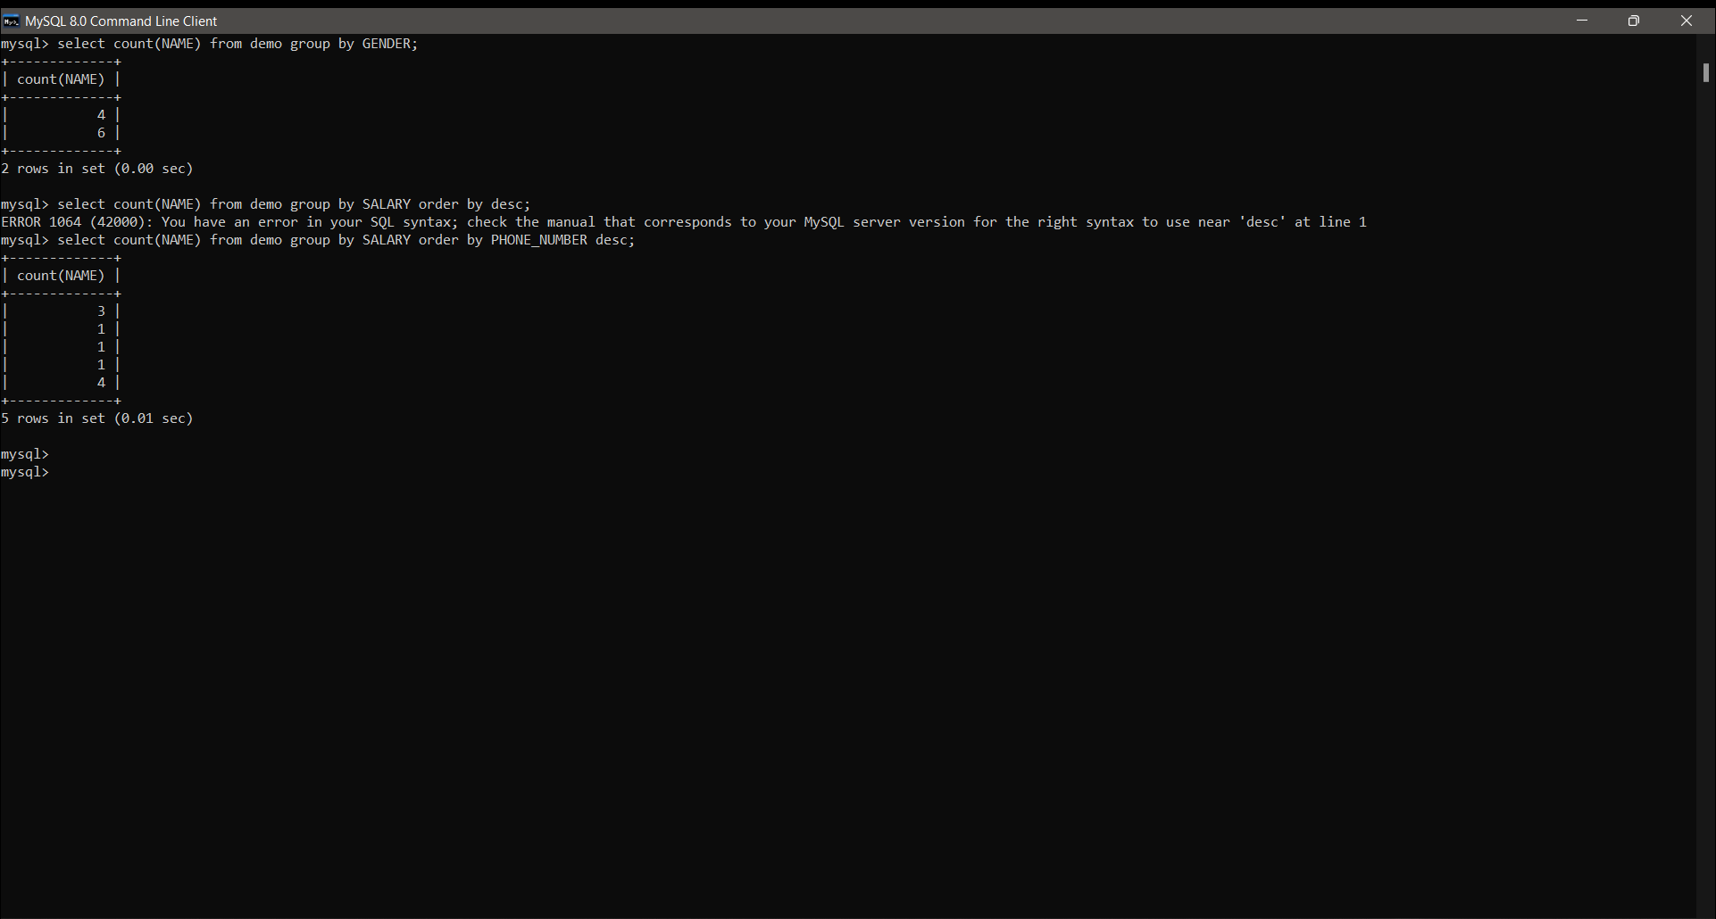



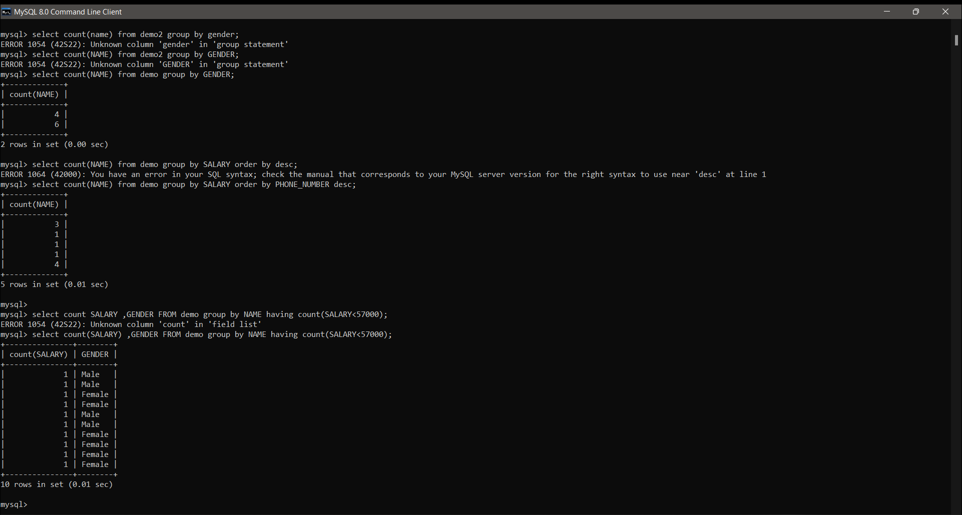

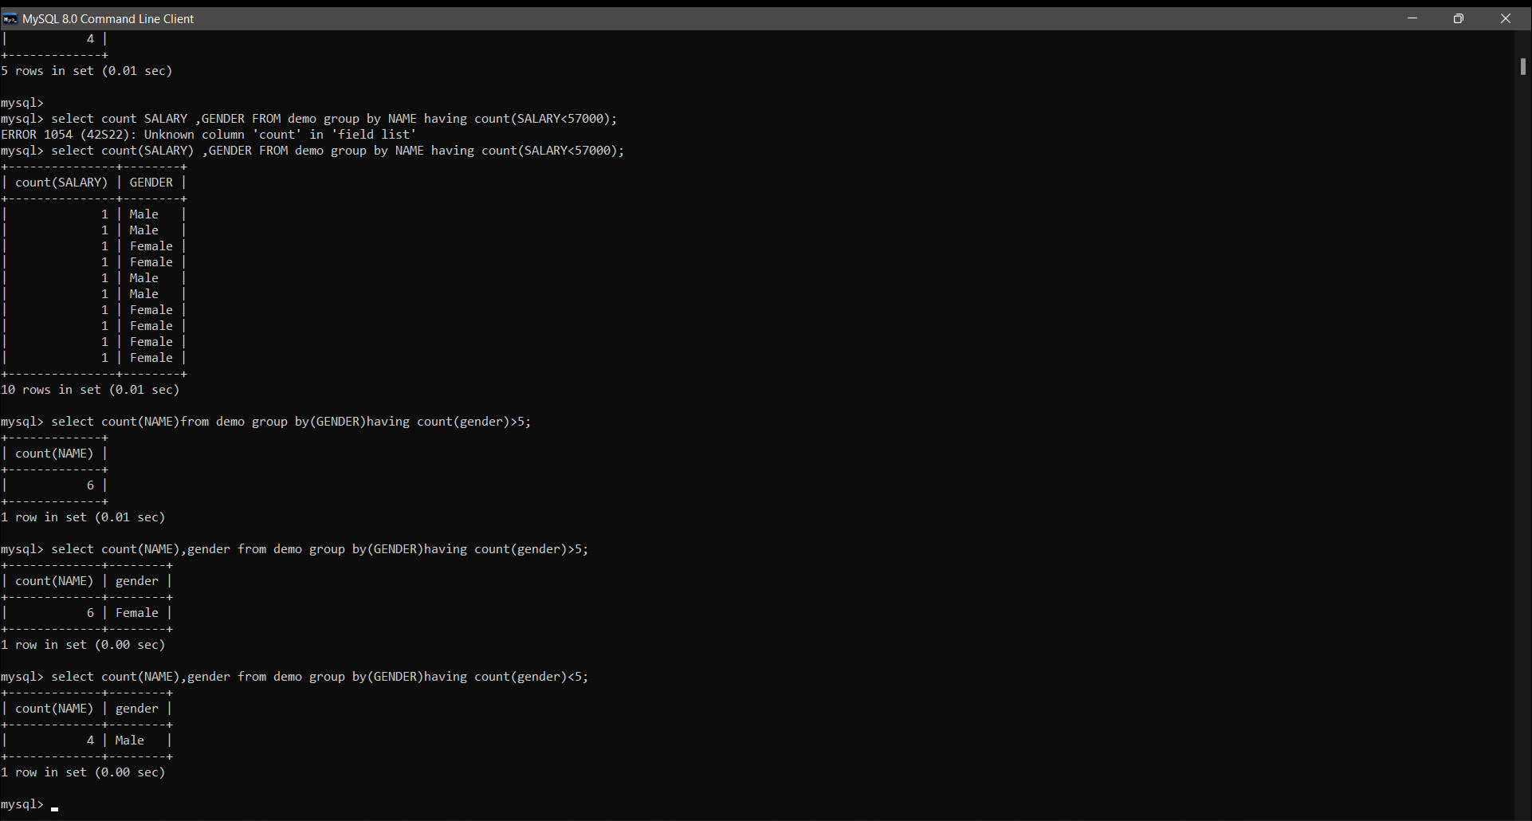

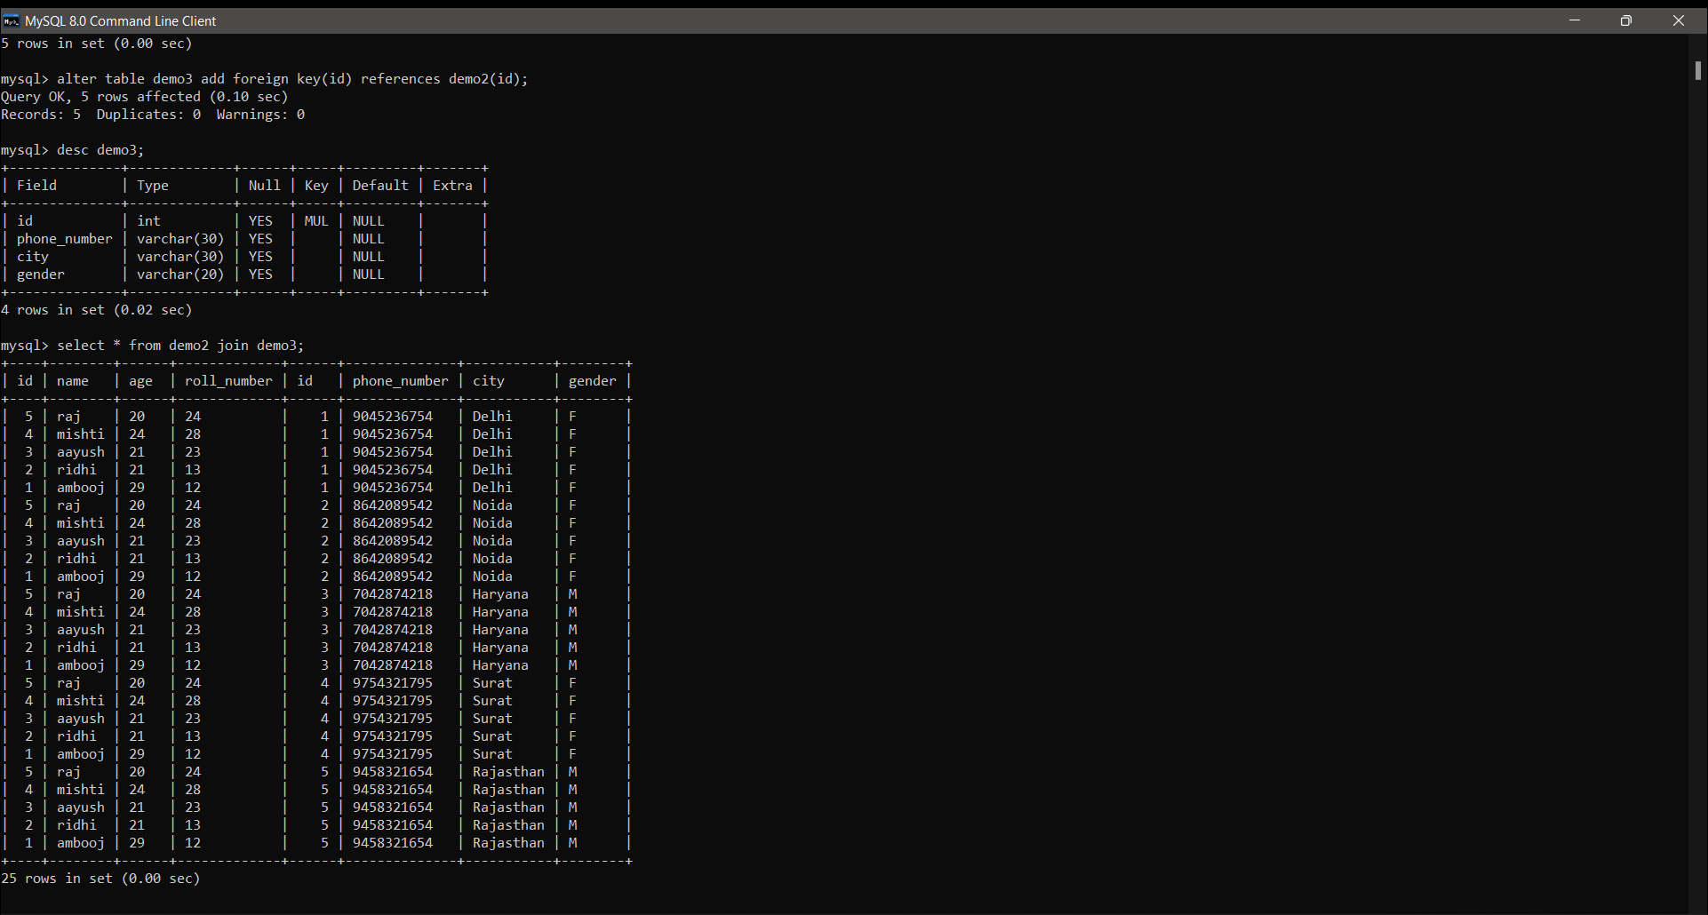

Multiplication



**Application Based Practicals**

13. **Consider the Insurance company’s Database given below. The primary keys are underlined and the data typesare specified.**

**•PERSON(driver_id# : string, name : string, address : string)**

**• cAR(regno : string, model : string, year : int)**

**• ACCIDENT(report_number : int, acc_date : date, location : string)**

**• OWNS(driver_id# : string, regno : string)**

**• PARTICIPATED(driver_id# : string, regno : string, report_number : int, damage_amount :number(10,2) )**

1. **Create the above tables by properly specified the primary key and the foreign key**
2. **(ii) Enter at least five tuples for each relation**
3. **(iii) Demonstrate how you can a. Update the damage amount for the car with a specific regno, the accident with report number 12 to 25000. b. Add a new accident to the database.**
4. **Find the total number of people who owned cars that were involved in accident in 2002.**
5. **Find the number of accident in which cars belonging to a specific models were involved**

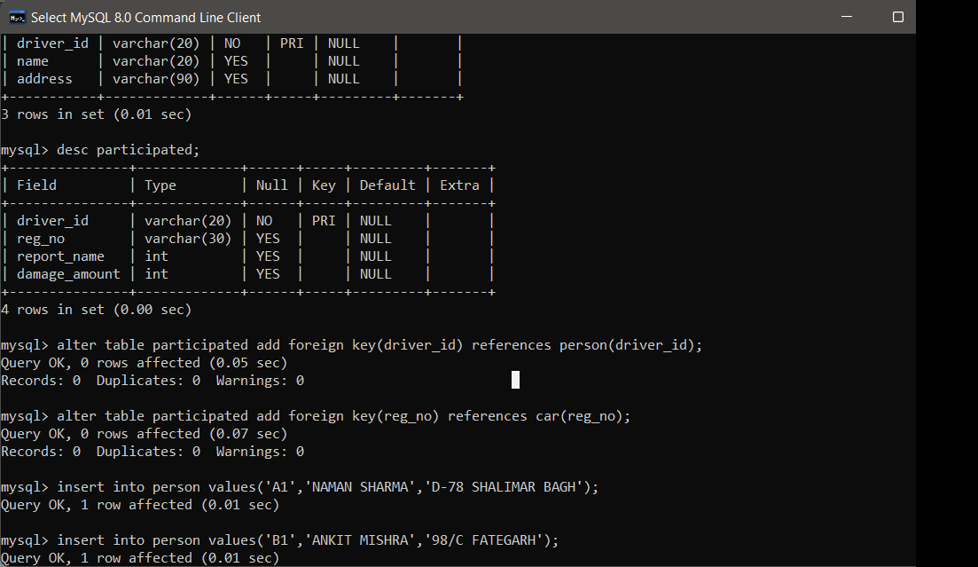

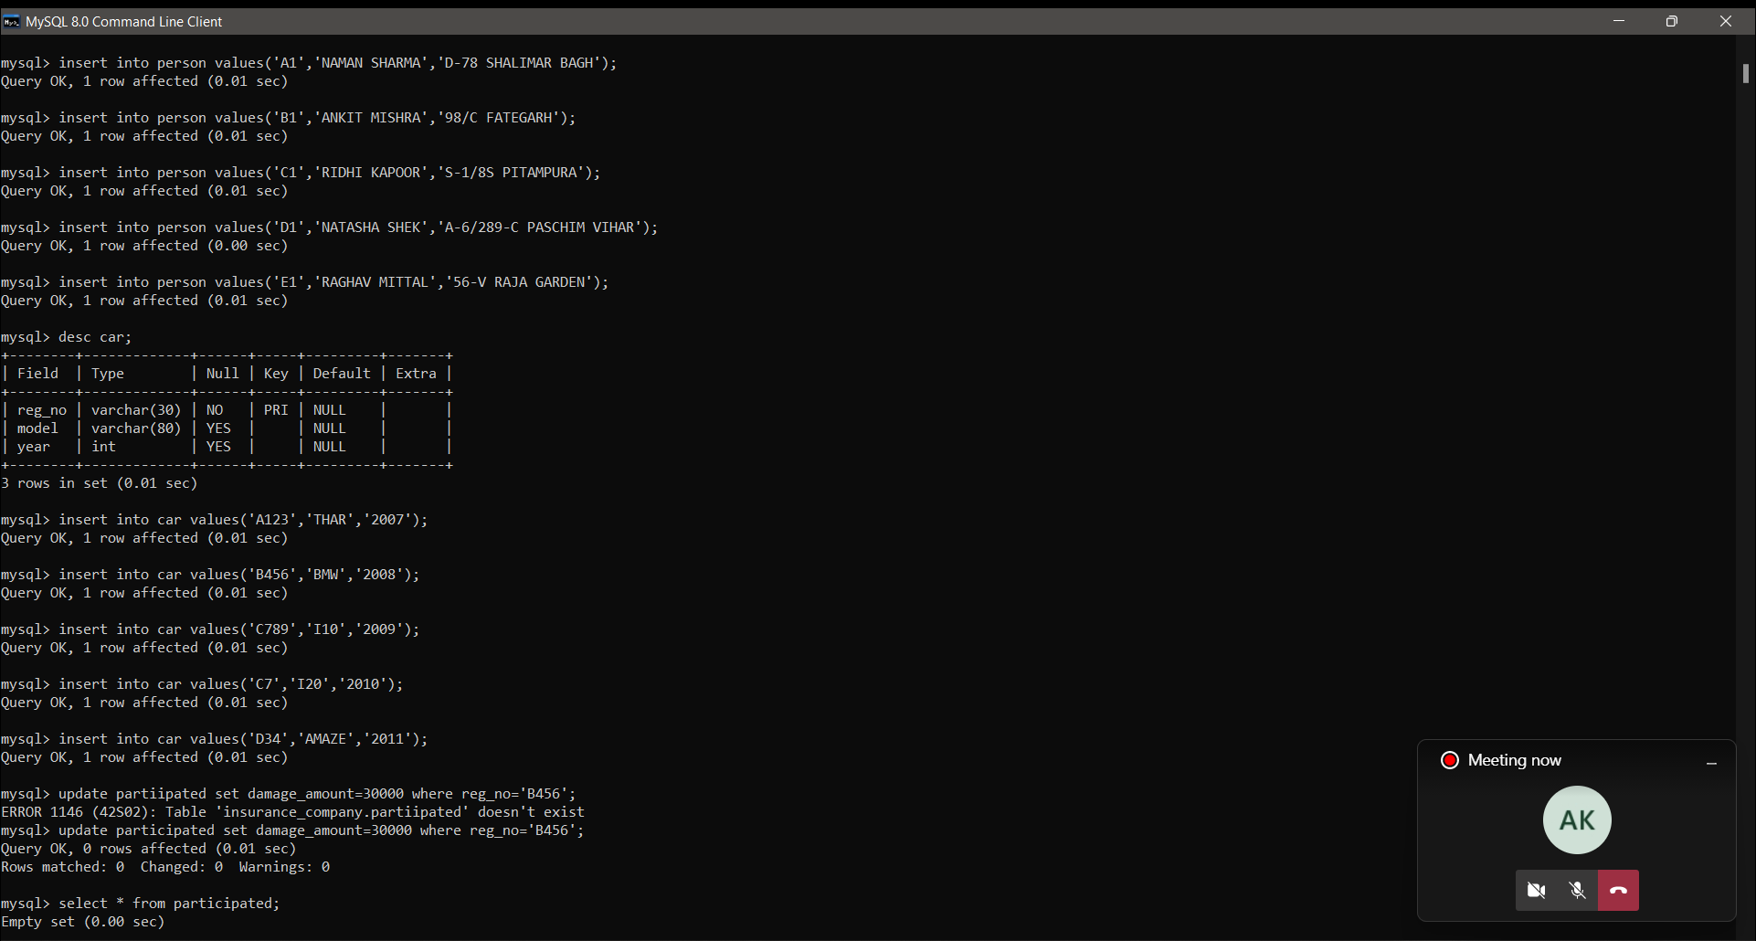



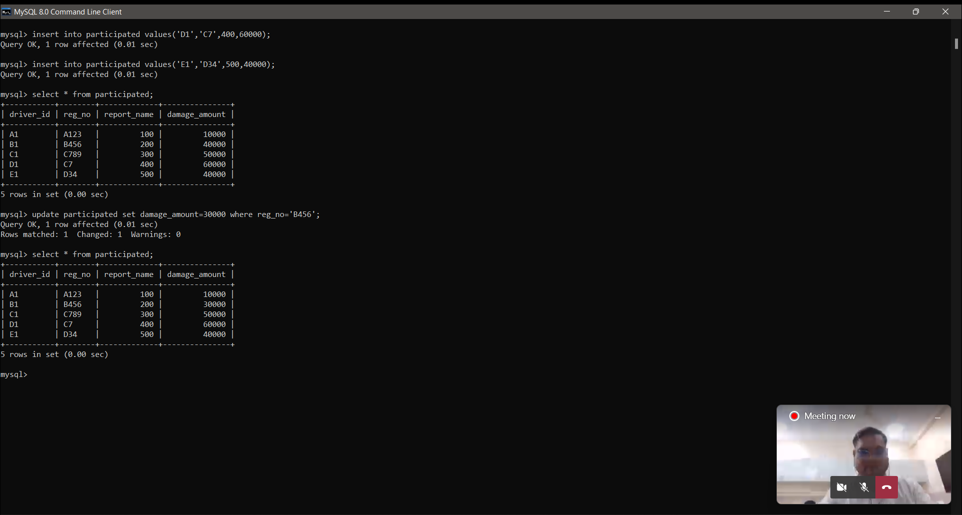

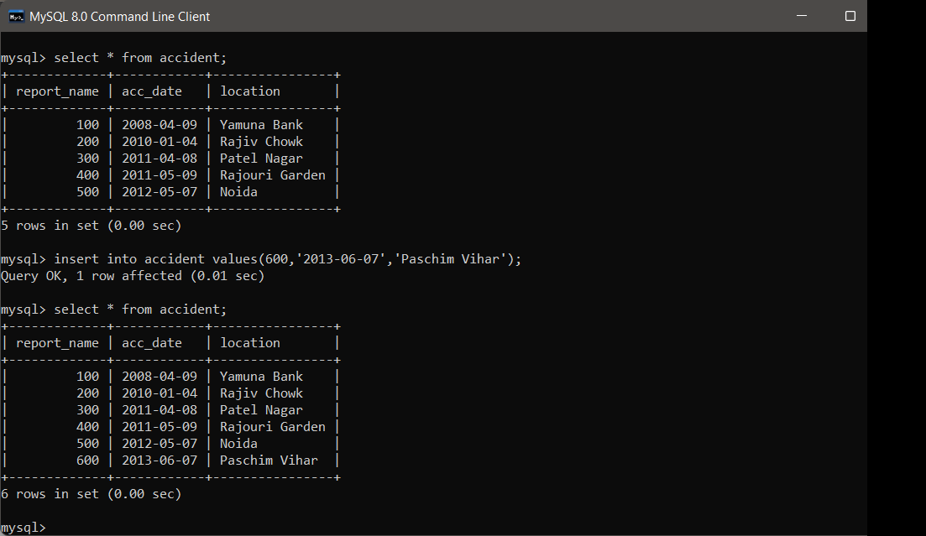

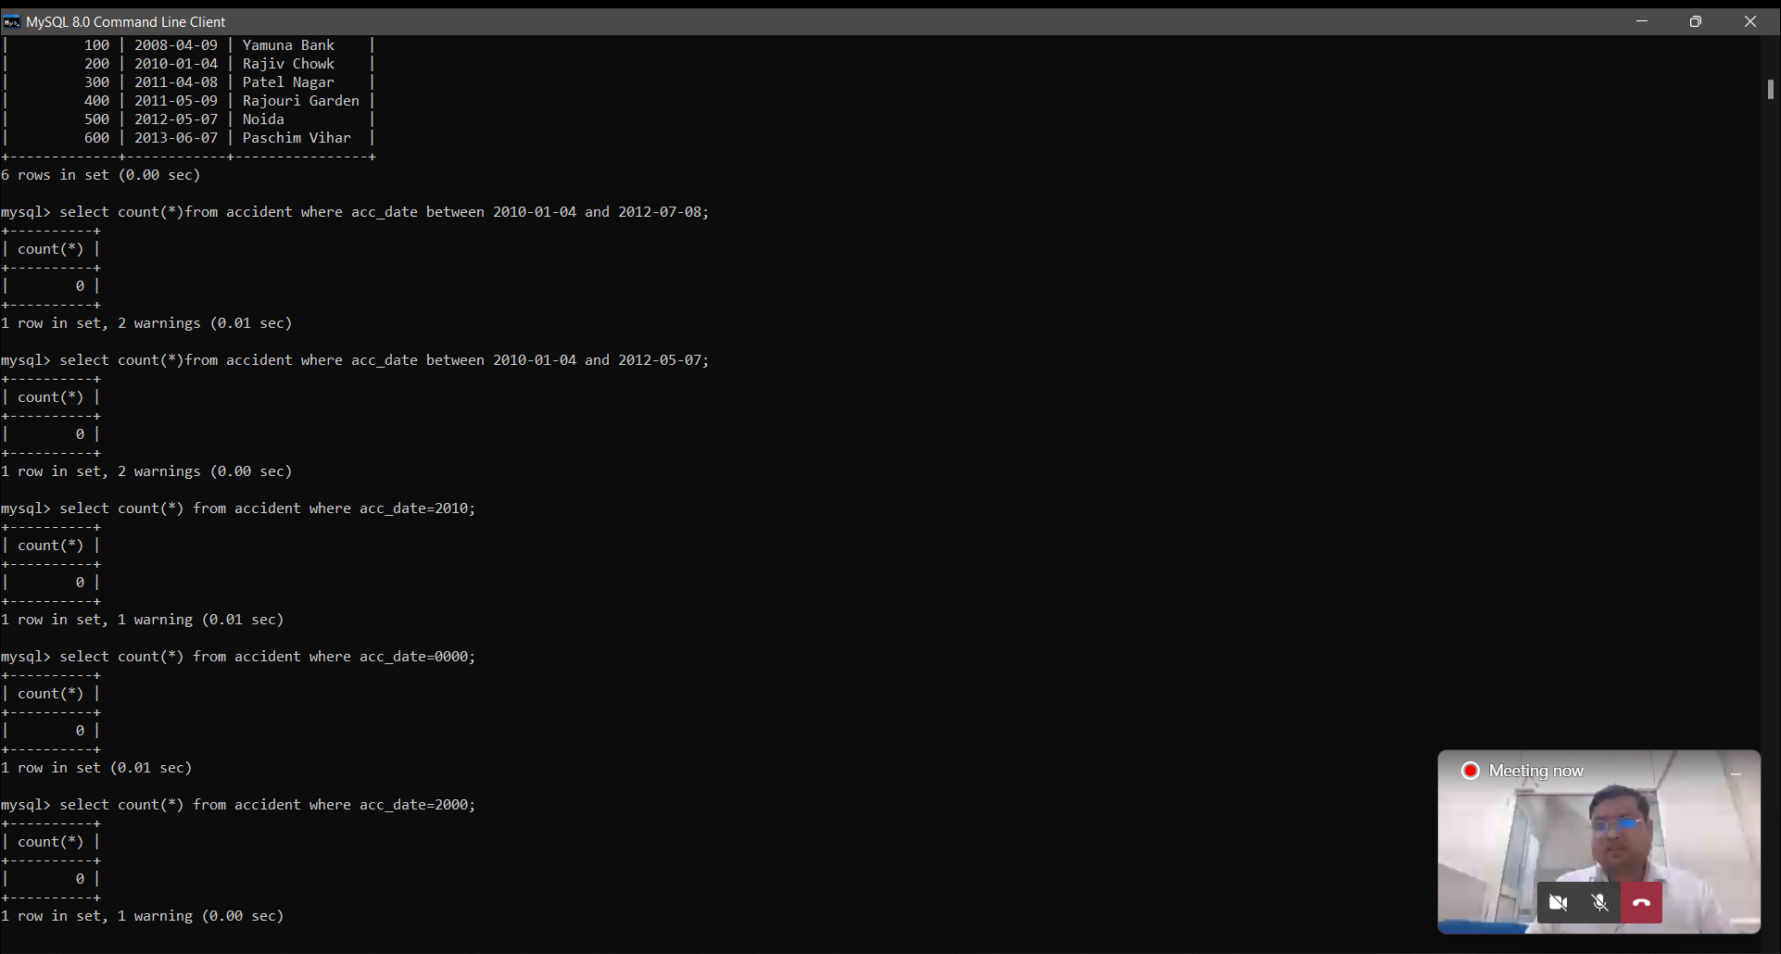

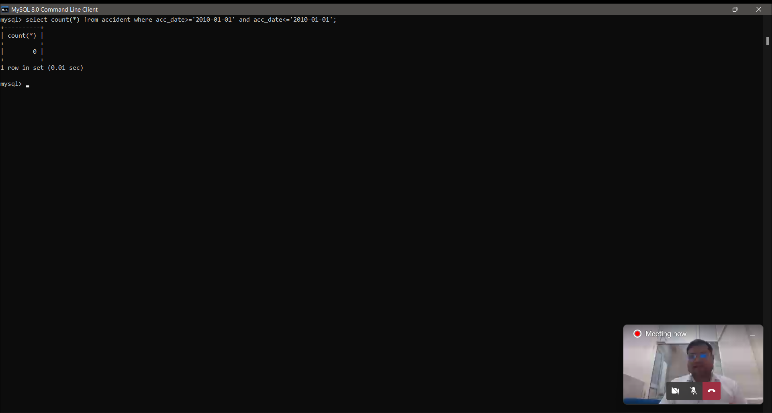

**14.Consider the following schema of a library management system .Write the SQL queries for the questions given below;**

**Student(Stud_no : integer, Stud_name: string)**

**Membership(Mem_no: integer, Stud_no: integer)**

**Book_(book_no: integer, book_name:string, author: string)**

**lss_rec_(iss_no:integer, iss_date: date, Mem_no: integer, book_no: integer)**

**(i)Create the tables with the appropriate integrity constraints**

**(ii) Insert around 10 records in each of the tables**

**(iii)Display all records for all tables**

**(iv)List all the student names with their membership numbers**

**(v) List all the issues for the current date with student and Book names CO7 Bachelor of Computer Applications**

**(vi) List the details of students who borrowed book whose author is Elmarsi & Navathe**

**(vii) Give a count of how many books have been bought by each student**

**(viii) Give a list of books taken by student with stud_no as 1005**

**(ix) Delete the List of books details which are issued as of today**

**(x) Create a view which lists out the iss_no, iss _date, stud_name, book name**

**(i)**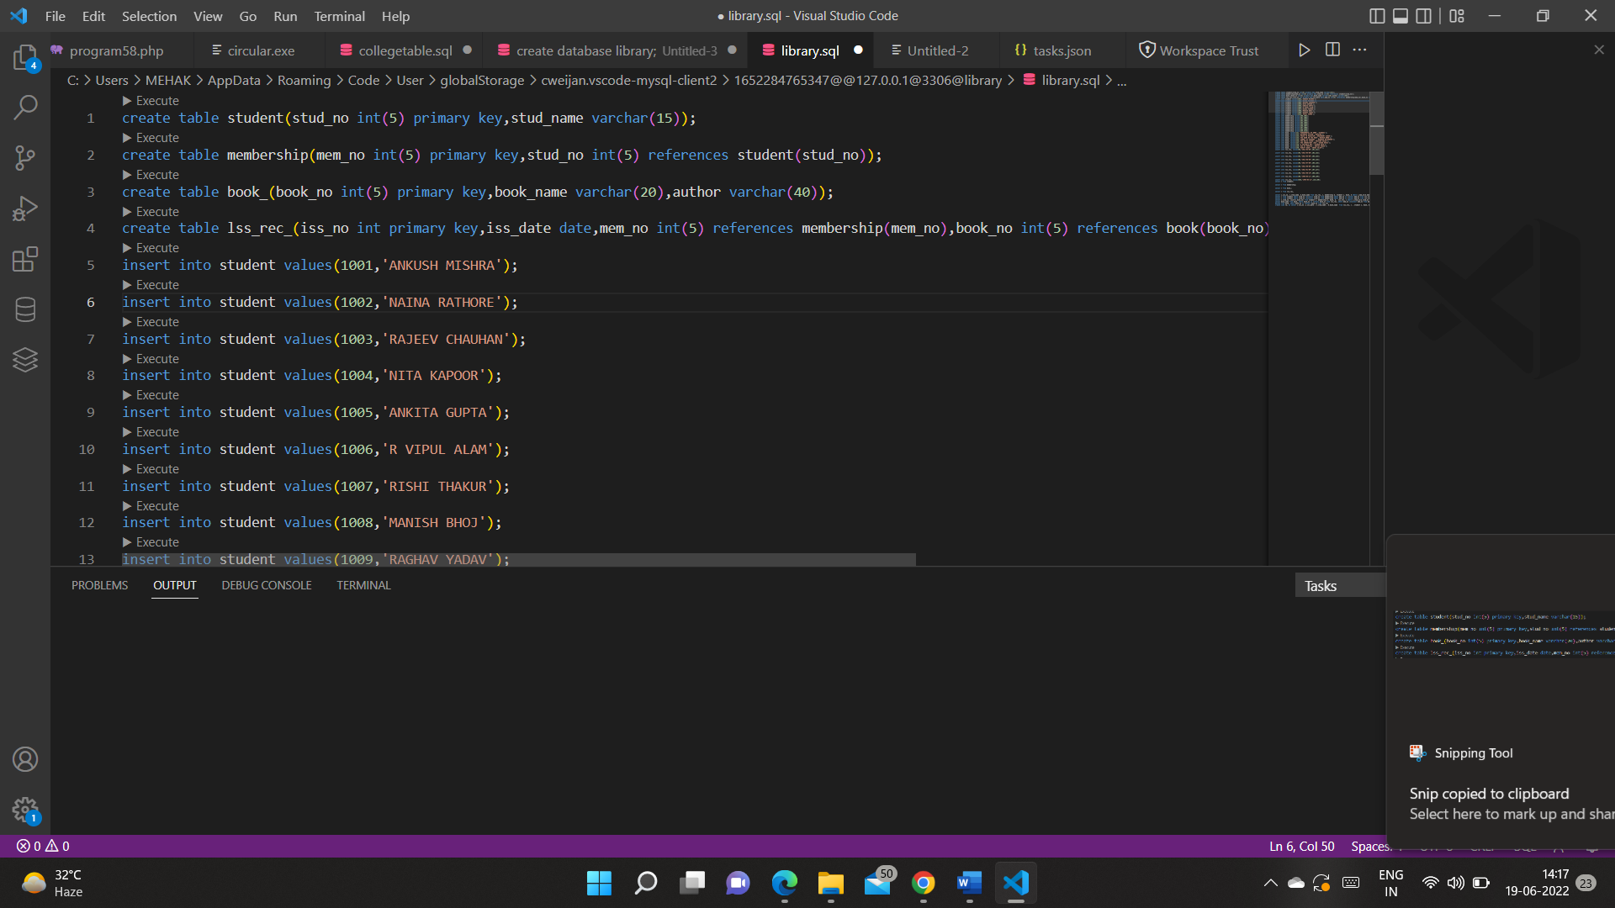

**(ii)**

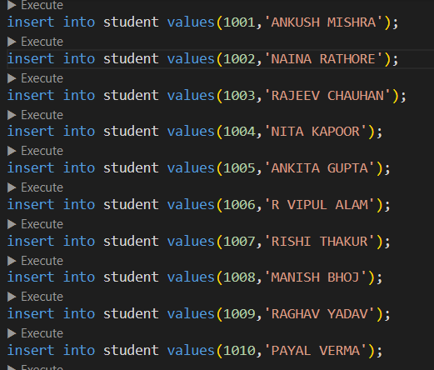 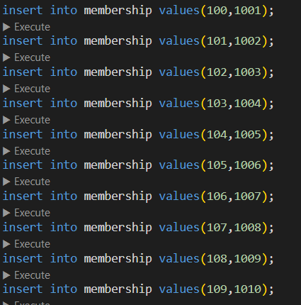

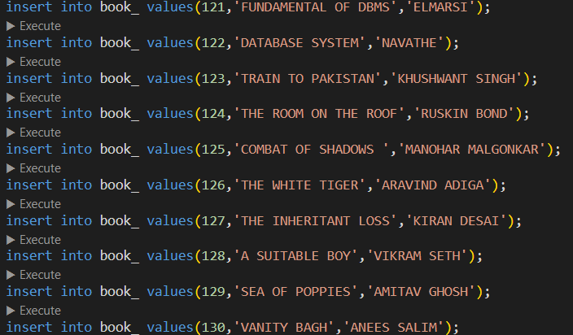 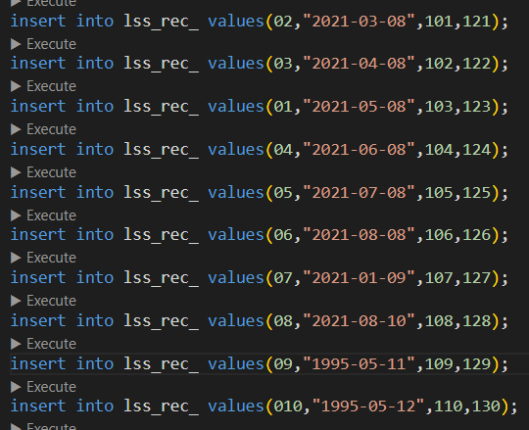

**(iii)**

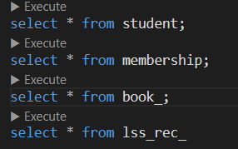

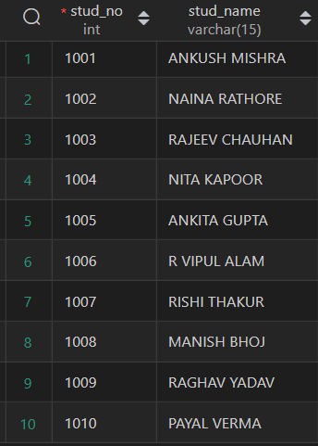 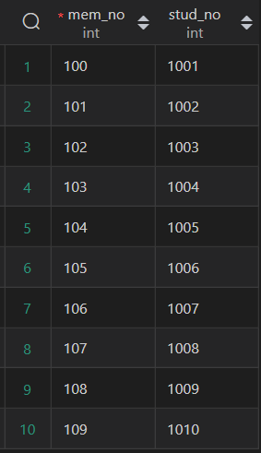 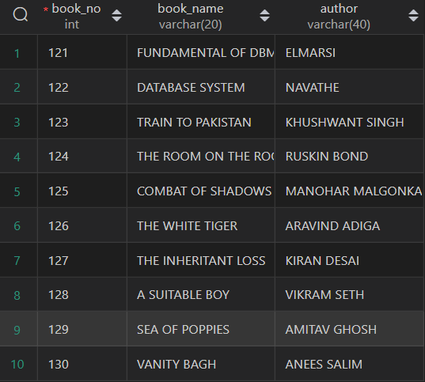

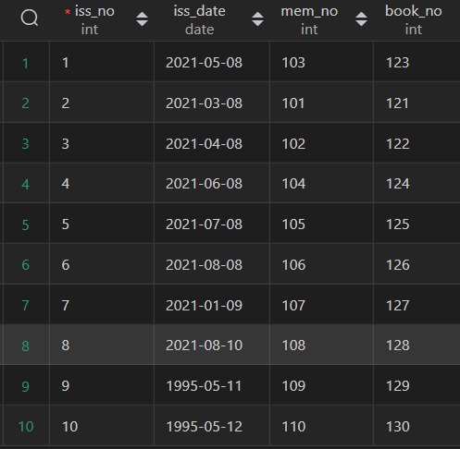

**(iv)**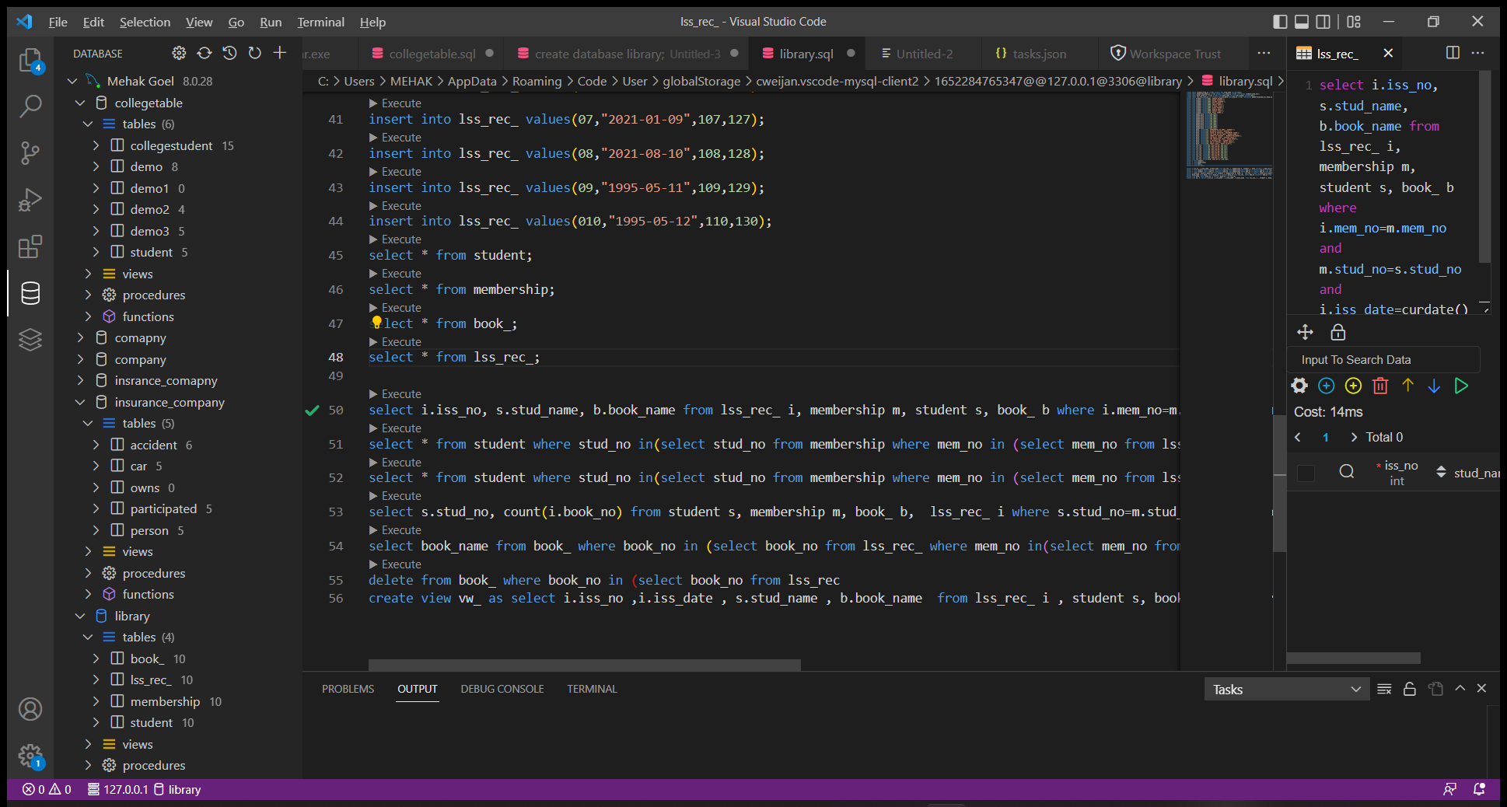

**(v)**

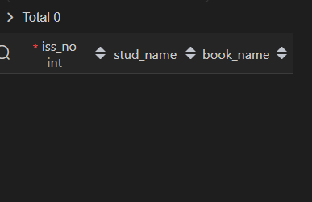

**(vi)**

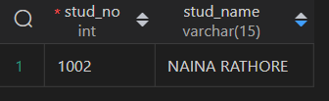

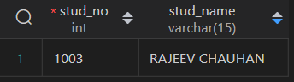

**(vii)**

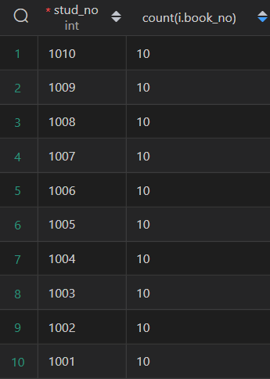

**(viii)**

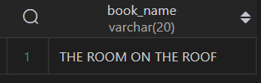

**(ix)**

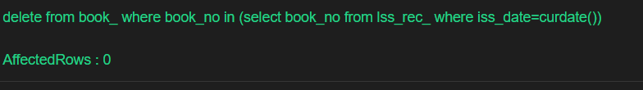

**(x)**

